



Job Description: Head of Housing Strategy, Improvement and Data

Waverley and Guildford are ambitious authorities, committed to being two of the leading Councils in the country at a time of major change by developing high performing, highly engaged staff teams to share the organisation’s values and deliver our corporate objectives.

Job Description
Job title: | Head of Housing Strategy, Improvement and Data
Service: | Housing Services
Team: | Housing Strategy, Improvement and Data Teams
Location: | The Burys, Godalming, Surrey, GU7 1HR and Millmead House, Guildford, GU2 4BB
Reporting to: | Director of Housing
Responsible for: | Providing assurance that RSH consumer standards are met, managing and developing improvement programmes, policy and performance data
Our shared Organisational Values
Collaboration   | We know, work with and support one another. We collaborate with residents, businesses and partners and realise the potential of the Guildford and Waverley Collaboration. We empower ourselves and others.
  Wellbeing | We look after our own and other’s wellbeing. We know it’s okay to talk to each other about anything we are struggling with. We stay resilient and raise any concerns we have.
Trusted   | We abide by the Nolan Principles of Public Life: Selflessness, Integrity, Objectivity, Accountability, Openness, Honesty, and Leadership.
Value for Money   | We spend public money wisely and carefully. We understand and follow our governance processes and raise any concerns with the right person. We celebrate successes and learn from mistakes.
Professionalism   | We provide professional advice and excellent service, we know our local areas and understand the communities we serve. We listen to all concerns and ideas. We benchmark our performance and always strive to improve.

Principal purpose of the role
- Responsible for the operational leadership for the Councils’ strategy, improvement and data functions across Guildford and Waverley Borough Councils. This role will shape the future of housing services, influence policy and strategy, and make a tangible difference to the lives of residents across both authorities.
- As a member of the Housing Leadership Team and direct report to the Director of Housing, the postholder contributes to the strategic development of housing services and ensures the effective delivery of corporate priorities, service plans, collaboration initiatives and continuous service improvement programmes strengthening performance, ensuring effective resource allocations and evidencing value for money through robust business cases.
- The postholder will provide leadership for housing service improvement and regulatory assurance across both councils. They will ensure housing strategies, plans and programmes are informed by robust evidence, resident insight, performance intelligence and an understanding of current and emerging housing legislation, regulation and sector best practice.
- The postholder will be the most senior operational lead responsible for providing assurance that RSH consumer standards are met, managing and developing improvement programmes, policy and performance data.
- Working collaboratively with housing leadership team, elected members, residents, partners, and stakeholders, the postholder will drive organisational improvement, and evidence-based policy development during a period of significant change and opportunity. They will ensure that housing services are informed by robust intelligence, meaningful resident insight, and a strong understanding of local housing needs, regulatory requirements, and emerging sector challenges.
- The role will act as the principal lead for housing intelligence, performance and organisational learning, to ensure that strategic decisions, investment priorities and service improvements are evidence-based and aligned to resident needs and corporate objectives.
- The role provides leadership and delivers strategic direction to ensure services are customer-focused, compliant with statutory and regulatory duties, financially sustainable, and aligned with the councils’ wider corporate priorities. With a strong focus on customer satisfaction, data governance and business intelligence, the postholder will support a culture of continuous improvement, ensuring that services are efficient, effective, compliant, and aligned with corporate priorities.
- The postholder and team works closely with residents to address issues, improve services, and foster safe, inclusive communities.
- Ensures that services are responsive to resident needs, organisational priorities and regulatory expectations, whilst fostering a culture of accountability, customer focus and continuous improvement.
Main duties and accountabilities
Operational Supervision
- Provide leadership, direction and daily support to service managers in line with Councils’ strategies policies and procedures. Empower them to deliver high quality housing services, achieve performance targets, take accountability for service outcomes, continuous improvement and resolve complex operational issues. Ensure staff are appropriately trained, developed and motivated to be responsible for appraising staff who report directly.
Strategic Leadership and Transformation
- Work closely with other Heads of Housing to lead service improvements and collaborative initiatives with responsibilities across both councils, ensuring the interests of both authorities are represented fairly and weighing this against the impacts and benefits this will have for Local Government Reorganisation.
- Maintain an awareness of legislative, economic, social and sector developments to inform service planning and future delivery.
Service Delivery, Resources and Performance
- Lead the delivery of Housing Strategy, Improvement and Data functions, managing budgets, resources, contracts and commissioning arrangements to achieve agreed service outcomes in line with service policies and strategies, deliver value for money and promote equality, diversity and inclusion in service delivery and employment. Ensure the effective use of performance information, business intelligence, resident insight and benchmarking to drive continuous improvement and evidence service outcomes. Create and write reports or delegate and oversee where appropriate.
Governance and Risk Management
- Ensure risks associated with your service are identified, managed and mitigated through effective governance, performance and business continuity arrangements including responsibility for relevant safeguarding, data assurance, health and safety, fraud and regulatory compliance requirements. Provide assurance that housing services meet statutory and regulatory requirements, including consumer standards and other applicable housing regulations.
Stakeholder Leader and Representation
- Build effective relationships with senior leaders, elected Members, staff, residents and partner organisations, demonstrating the Councils’ leadership competencies and values. Provide professional advice and recommendations on matters relating to the service housing strategy, performance, improvement and regulatory assurance and represent the Councils at committees, partnership forums and external meetings as required. Work closely with communications and customer services teams to ensure appropriate systems and data is in place to keep residents informed of relevant issues.
Business Continuity
- Play a pivotal role in business continuity planning and should the need arise assist in ensuring business recovery of key service provision in a 24 hour window.
- Health and Safety
Comply with all Health and safety legislation for your area of work, ensuring that risks are identified, managed and monitored as required

Dimensions of the role
- Budget for both Councils including IT: circa £7M (Waverley circa £4M, Guildford circa £3M).
- Housing stock: 10,000+ properties
- Reports to: Director of Housing
- Staff: 25
- Number of direct reports: Up to six
- KPI suite: LADR, LAHS, TSMs and Corporate and contract KPIs
Areas of Accountability/Problem Solving – Decision Making / Scope for Impact
- Provide clear leadership and direction to up to six managers and their teams, ensuring integrated service delivery across housing functions and alignment within corporate priorities.
- Contributes to the development and delivery of the Housing Revenue Account Business Plan, balancing service demands, investment priorities, regulatory requirements and long-term financial sustainability.
- Resolve complex operational, regulatory and compliance challenges, exercising professional judgement in the interpretation of legislation, policy and competing service priorities, whilst empowering managers and intervening on high-risk or sensitive issues within delegated authority.
- Make strategic and tactical decisions on resource allocation, service priorities, and performance optimisation against budgets.
- Oversee the delivery and continuous improvement of all housing services and provide assurance data that all legislative and regulatory requirements are met.
- Develop and manage performance frameworks, monitoring delivery, statutory compliance, and resident satisfaction through KPIs.
- Embed meaningful resident engagement into service design, using complaints and feedback to inform improvements and innovation.
- Lead business continuity planning and ensure rapid service recovery and health and safety compliance, especially in emergency situations.
- Use data insights and resident feedback to drive service improvements, modernisation, and cultural transformation.
- Promote innovation and digital enablement to enhance service efficiency and resident experience.
- Influence service outcomes for residents, ensuring homes are safe, secure, and well-maintained.
- Represent housing services at a senior level, driving collaboration across internal teams and with partners (e.g. Guildford Borough Council) to align strategies and share best practice.
- Uphold the council’s housing objectives, ensuring legal and regulatory compliance and maintaining public trust in a high-profile service area.
- Lead the development of housing strategies, policies, assurance frameworks and improvement programmes that have a significant impact on service delivery, resident outcomes and organisational performance.
- Exercise professional judgement in interpreting legislation, regulatory standards, housing data and performance information to inform strategic recommendations and organisational decision making.
Planning/Organising/Controlling
- This is a fixed-term role. The postholder will lead the delivery of the following priorities whilst planning for future service requirements, opportunities and challenges to support the longer-term development of housing services across both councils and Local Government Reorganisation.
- Leads the development, implementation and monitoring of annual and medium term service plans across key housing functions.
- Contributes to long-term strategic planning through strategies, management plans and investment programmes to ensure the service meets the future needs of residents.
- Anticipates service demands and aligns workforce, financial, and operational planning to ensure continuity, resilience and efficient resource use.
- Structures and coordinates a team of cica 25 staff.
- Establishes clear team structures, to deliver high quality resident-focused services. With performance frameworks that reflect statutory obligations, best practice, and council priorities.
- Oversees performance monitoring and reporting activities against budgets, performance frameworks and improvement plans using data insights and KPIs to drive accountability, continuous improvement, and service development.
- Ensures housing services meets regulatory, statutory and policy requirements, including health and safety compliance and service-level agreements.
- Monitors and manages substantial financial resources, ensuring effective financial control and value for money.
- Implements robust contract management and governance practices to assess and improve contractor performance.
- Leads business continuity and risk management planning to ensure critical services are resilient and recoverable in the event of disruption.
- Lead the preparation, implementation and monitoring of strategic housing plans, improvement programmes and policy frameworks, ensuring delivery against agreed objectives and regulatory expectations.
- Ensure the Council maintains robust intelligence relating to housing need, resident satisfaction, service performance and emerging risks to support effective planning and resource allocation.

Customers and Contacts
Internal
- Director of Housing Services.
- Housing Strategy Improvement and Data Managers and Teams (see service/team structure).
- Heads of Housing (Leadership Team)
- Corporate Leadership Team.
- Enabling teams including but not exclusive to Finance, Legal ICT, Customer Service, Environmental Service, Regulatory Service, Communications and People and OD Teams.
- Enabling teams including but not exclusive to Finance, Legal ICT, Customer Service, Environmental Service, Regulatory Service, Communications and HR Teams.
- Elected Members.
- Staff at all levels.
External
- Residents, Tenants and Leaseholders.
- Engaged Tenants groups.
- Contractors and Suppliers.
- Partner Organisations (e.g. housing associations, social care providers).
- Regulator of Social Housing.
- Local Authorities and Public Sector Bodies
- Housing and Local Government Ombudsman Service

Service/Team Structure
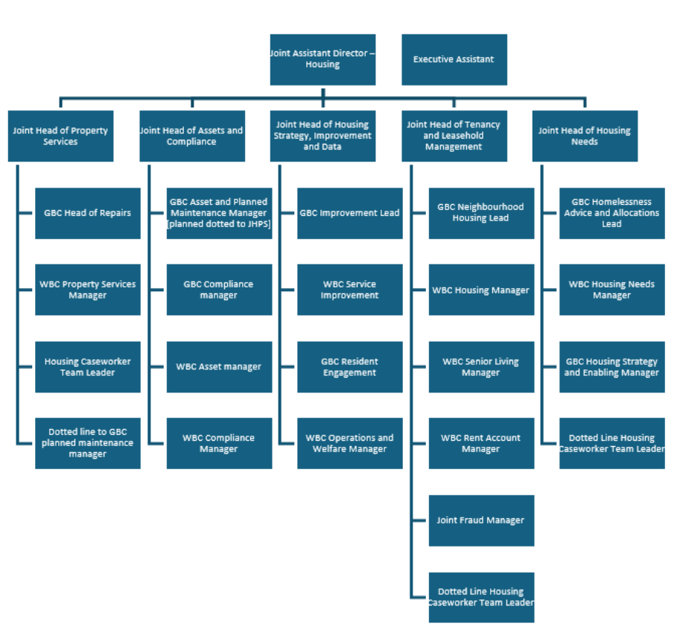
*Role outlined in red

PERSON SPECIFICATION

Candidates must be able to demonstrate, giving examples, all essential criteria marked as A, A/C or A/I within their application form to be shortlisted for this role.

 | Person Specification
 | Essential criteria | How Assessed | Desirable criteria | How Assessed
Qualifications/ Education / Training / Experience | Relevant professional qualifications in housing, management, or a related field. | C/A | Postgraduate qualifications in housing or management. | C/A
Qualifications/ Education / Training / Experience | Evidence of continuous professional development. | C/A | Member of the Chartered Institute of Housing | C/A
Qualifications/ Education / Training / Experience | Extensive experience in leading and managing housing services at a senior level | A/I
Qualifications/ Education / Training / Experience | Broad experience in delivering cultural and operational change within a complex organisational environment. | A/I
Qualifications/ Education / Training / Experience | Proven track record of working at a senior level in a politically sensitive environment, supporting strategic leadership, and contributing to organisational decision-making. | I
Qualifications/ Education / Training / Experience | Experience in managing complex budgets and resources effectively and achieving value for money in service delivery. | A
 | Experience of procurement, contract management and commissioning services. | A/I
 | Experience of developing successful partnerships with public, private and voluntary sector organisations. | A/I
Knowledge /Technical Skills | In-depth knowledge and experience of housing, services in role including RSH consumer standards, programme management, strategy and policy development. | A/I | Awareness of Safeguarding | A/I
Knowledge /Technical Skills | Proven leadership skills with the ability to manage change and develop, motivate and support a range of staff | A/I | Experience of working with the Regulator of Social Housing. | A/I
Knowledge /Technical Skills | Extensive understanding of statutory and regulatory requirements relevant to the role | A/I | Experience of leading housing strategy, service improvement or regulatory compliance functions within a social housing environment. | A/I
Knowledge /Technical Skills | Application of performance management frameworks and the use of data and insights to drive improvements. | I
Knowledge /Technical Skills | Strong analytical and problem-solving skills to interpret data, identify trends, and develop solutions. | I/E
Communication | Excellent verbal and written communication skills to engage with a range of stakeholders, including residents, contractors, and senior leadership. | A/I
Communication | Ability to present complex information clearly and effectively to various audiences, including reports to elected members, exercising discretion and sound judgement in the management of sensitive and confidential information. | I
Customer Service | Understanding of and commitment to promoting equality and diversity in service delivery and employment. | I
Customer Service | Accurate spoken English is essential for the post with frequent public interactions. | I
Customer Service | Commitment to delivering resident-focused services that prioritise safety, quality, and satisfaction. | A/I
Customer Service | Skilled in handling complaints transparently and ensuring lessons learned inform service improvements. | A/I
Customer Service | Ability to engage with residents meaningfully and use feedback to shape services | A/I
Team Working | Proven ability to work with other Heads of Service, and empower and support managers to deliver high-performing services. | I
Team Working | Skilled in fostering collaboration, across teams and breaking down silos to achieve common objectives. | I
Team Working | Strong leadership skills to motivate teams and embed a culture of accountability and continuous improvement. | I
Managing self and others | Strong leadership and strategic thinking skills. | A/I
Managing self and others | Ability to manage and develop staff effectively whilst managing stakeholder expectations. | I
Can do approach / Achieving results | Highly organised with the ability to prioritise multiple demands and deliver against challenging deadlines. | I
Can do approach / Achieving results | Skilled in managing resources efficiently, including financial and staff management. | A/I
Can do approach / Achieving results | Ensure that relevant KPI/data necessary to inform and support the service is gathered, challenged and presented to key stakeholders whilst monitoring progress and achieving targets. | A/I
ADDITIONAL SPECIFIC REQUIREMENTS FOR THIS POST* | For business continuity purposes you are required to have access to the internet at home via broadband on a PC or laptop. | A
ADDITIONAL SPECIFIC REQUIREMENTS FOR THIS POST* | Ability to travel around the borough | A/I
ADDITIONAL SPECIFIC REQUIREMENTS FOR THIS POST* | Ability to attend evening meetings when required | I
ADDITIONAL SPECIFIC REQUIREMENTS FOR THIS POST* | Required to work in office minimum of 2 days a week | I

How assesed:

A = Application CV/Personal Statement
C = Certificates/professional Registration
D = DBS police check
E = Exercise
I = Interview
M = Medical assessment

Disclosure and Barring Service Check
Due to the nature of the work, this post involves a check on an individual’s criminal background. The check is carried out through the Disclosure and Barring Service. Any offer of employment will be subject to receiving satisfactory clearance from the Disclosure and Barring Service.

Politically Sensitive post: Political Restrictions
Please note that the Local Government Officers (Political Restrictions) Regulations 1990 apply to this post. In general terms these provisions mean that the postholder is prohibited from:
• holding or standing for elected public office (except Town or Parish Councils);
• holding office in a political party;
• speaking or writing in public (including on social media) in a personal capacity in a way that might be regarded as favouring one or other political party;
• canvassing at elections

Behavioural competencies:

COMPETENCIES  (LEVEL 1 – 4) | Communication: | 4
COMPETENCIES  (LEVEL 1 – 4) | Customer Service: | 4
COMPETENCIES  (LEVEL 1 – 4) | Team Working: | 4
COMPETENCIES  (LEVEL 1 – 4) | Managing Self and Others: | 4
COMPETENCIES  (LEVEL 1 – 4) | Can do approach/Results: | 4
Reviewed By: |  | Date:
Checked in: | HR | Date:
Last Updated: | Add date | Date:
For Official Use only
Job title: | Head of Housing Strategy Improvement and Data | Post no:
Service: | Housing Service | JE score:
Team: | Housing Strategy Improvement and Data teams | Pay band: | 2
Location: | The Burys, Godalming, Surrey, GU7 1HR and Millmead House, Guildford, GU2 4BB | Position type:  (if part time, working pattern) | Full time  37 Hours/ Five day week

