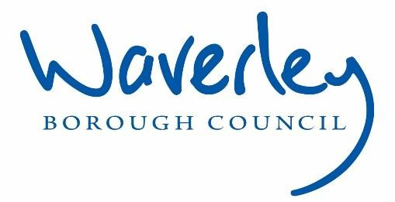

JOB DESCRIPTION
Job title: | Compliance Support Officer
Service: | Housing Operations
Team: | Property Services Team
Location: | The Burys, Godalming, Surrey, GU7 1HR
Reporting to: | Mechanical & Electrical Manager
Responsible for: | NA
OUR ORGANISATIONAL VALUES
Openness | In Waverley we value openness and honesty where communication is clear and constructive and actions are transparent.
Excellence | In Waverley we value excellence, working in a consistent and professional way to achieve the highest standards possible, taking the time to recognise and celebrate success.
Fairness | In Waverley we value fairness and respect, working with integrity to ensure that everyone is treated well and has equal access to the opportunities available.
Team Work | In Waverley we value team work and collaboration, with approachable staff actively contributing to our shared corporate goals.
Taking Ownership | In Waverley we value taking ownership, where everyone feels personally committed to issues at hand and is working towards a positive outcome.
PRINCIPAL PURPOSE OF THE ROLE
- Support the Team with administrative duties with regards to agenda, meetings and minutes.
- Support the Compliance Manager and Compliance Team with management of compliance data and administrative duties
- To support the delivery of a high quality, effective and customer focused service to the Compliance Arena.
- Maintain the compliance inbox, Sharepoint folders and documents

MAIN DUTIES AND ACCOUNTABILITIES
Operational Duties
- Liaise with the Compliance Officers, contractors and Systems Project Officer to ensure correct data is sent to contractors and data from all of the compliance contractors is centrally collated, recorded on our central database
- Work with the Systems Project Officer with regards to monthly or ad hoc reporting requirement statistics, produce data charts, trend analysis.
- Be responsible for the compilation of compliance figures for reporting purposes from Compliance Officers, M&E Manager and Regulatory Compliance Manager for Tenant Satisfaction Measures, Key Performance Indicators reporting and any other monthly reporting.
- Maintain accurate records
- Ensure that all compliance records, contractor records, certification and management systems are current and updated, ensuring adherence with data protection and GDPR requirements.
- Provide support, assistance and cover across the Compliance Team and the wider Property Service Team when required.
- To support with raising bulk orders for contractors as approved by relevant members of the team.
- To support with administrating ‘no access’ procedures including the escalation of cases, mail merges, legal referrals and data recording
- To manage the Compliance email Inbox and cascade queries to relevant officers and respond accordingly.
Finance and Budgets
- Raise Orchard works orders as required.
- Check invoices for accuracy within financial management systems.
- Provide information to the Managers within the team, and Housing Operations Managers as required for budgeting and business planning purposes.

Team Work and Communication
- Work as part of a key part of the Compliance Team to ensure resilience and continuity of the compliance work streams
- Work in partnership with contractors, colleagues (from Property Services and the wider Housing and Corporate services) to take holistic approach to service delivery.
- Liaise with residents undergoing works in their homes to provide information, dealing with their needs sensitively, explaining technical plans or specifications to a non-technical audience. Actively participate in contractor meetings and participate in the management of contractor duties.

Customer Service
- Corporate – Deliver excellent service to customers in line with published service standards
- Equality & Diversity – Actively promote the Council’s Equality and Diversity policy in all aspects of your duties.
- Safeguarding – Adhere to effective safeguarding practice for vulnerable adults and children in accordance with the Council’s policies, guidance and protocol.
- Dignity and Respect – Treat all colleagues with dignity and respect whilst at work so that they are able to, and encouraged to meet their full potential y working in a non-threatening environment free of harassment and/or bullying.
- Data Protection (GDPR) – Ensure that the principle of confidentially and the requirements of the Data Protection Act (and future GDPR requirements) are fully applied to the work of your service area.
- Information Sharing – Work in line with the relevant protocols and service level agreements to enable the effective sharing of information between agencies.

Service Development and Improvement
- Contribute to service development plan and provide innovative solutions to improve services
Investigate new initiatives for compliance management, products and systems, sharing ideas with the Compliance Manager.
Health and Safety
- Comply with all Health and Safety legislation for your area of work, ensuring that plans are prepared and adhered to and risks are identified, managed and monitored as required.

DIMENSIONS OF THE COMPLIANCE TEAMS ROLE
- Gas Safety Checks completed annually - circa 4000
- Legionella Checks completed annually – circa 300
- Fire Risk Assessments (including reviews) completed annually – circa 300
- Fire Safety Remediation works following assessment - 300
- Electrical Tests completed annually - circa 900
- Asbestos management surveys completed annually – circa 600
- Lift Services completed (stair/passenger) completed annually – circa 60
- Combined contracts responsible – approximately 16

AREAS OF ACCOUNTABILITY
- Develop a strong understanding of the contracts you are administrating
- Processing high volumes of data and certification from compliance contractors.
- Develop knowledge of the Councils key Compliance Policies and Procedures
- Achieve agreed objectives set with the Compliance Manager, with measurable success indicators

PLANNING/ORGANISING/CONTROLLING/ PROBLEM SOLVING/ DECISION MAKING / SCOPE FOR IMPACT
- Provision of technical systems advice and expertise for all enquiries to do with the compliance data management, in order to assist with solving problems by implementing action plans which will minimise risk and liability for the Council.
- Making court applications.
- Provide information to the team Managers to respond to complaints or Council Member enquiries.
CUSTOMERS AND CONTACTS
INTERNAL
- All staff including Management Board, Executive Members including the portfolio holder for Housing Services and Ward Members
EXTERNAL
- Contractors, suppliers, service providers, tenant and resident groups, partnering agencies, leaseholders and members of the public.
•
SERVICE/TEAM STRUCTURE
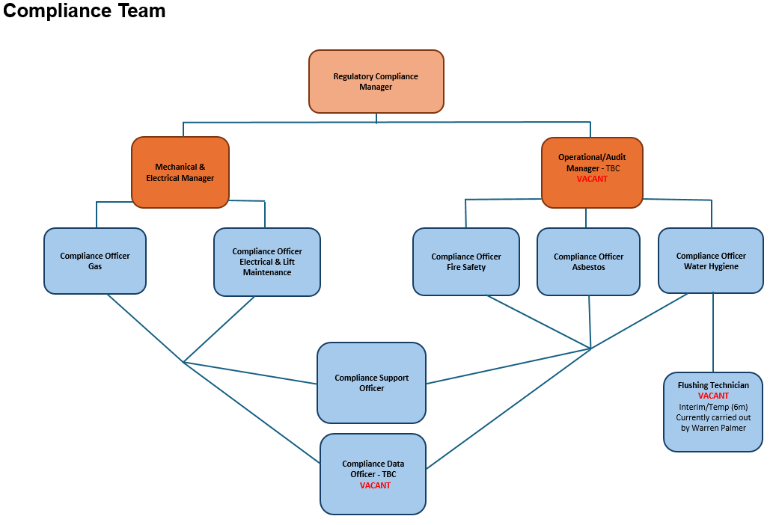

PERSON SPECIFICATION

Candidates must be able to demonstrate, giving examples, all essential criteria marked as A, A/C or A/I within their application form to be shortlisted for this role.

 | PERSON SPECIFICATION
 | ESSENTIAL CRITERIA | HOW  ASSESSED | DESIRABLE CRITERIA | HOW  ASSESSED
QUALIFICATIONS/  EDUCATION /  TRAINING /  EXPERIENCE | Good general standard of education at GCSE level or equivalent.  Evidence of literacy and numeracy. | A/C | Knowledge of Housing /compliance systems | A/I
QUALIFICATIONS/  EDUCATION /  TRAINING /  EXPERIENCE | Well-developed IT skills with good knowledge and skills of Microsoft Office at intermediate to advance level. | A/I | Member of recognized professional body – or working towards membership | A/C
QUALIFICATIONS/  EDUCATION /  TRAINING /  EXPERIENCE | General administrative / clerical experience | A/I
KNOWLEDGE  /TECHNICAL  SKILLS | Experience of project administration | A/I | Knowledge of social housing and tenancy agreements including no access procedures. | A/I
KNOWLEDGE  /TECHNICAL  SKILLS | Good Knowledge of health and safety practices | A/I | Experience of dealing with vulnerable residents | A/I
KNOWLEDGE  /TECHNICAL  SKILLS | Well-developed IT skills with knowledge of Microsoft Office at intermediate to advance level.  Ability to use and understand  Databases and Excel to an advanced level. With ability to analyse large quantities of data. | A/I | Awareness of Safeguarding | A/I
KNOWLEDGE  /TECHNICAL  SKILLS |  |  | Budgetary management experience and cost control. | I
KNOWLEDGE  /TECHNICAL  SKILLS |  | I

COMMUNICATION | Understanding of and commitment to promoting equality and diversity in service delivery and employment.  Demonstrates a wide  range of communication  methods most  effective for the situation and individual needs. | I | Experience of producing reports in a variety of formats to be presented at operational, corporate or strategic levels. | A/I
COMMUNICATION | Accurate spoken  English is essential for the post | I
CUSTOMER  SERVICE  TEAM WORKING | Demonstrate the ability to obtain and analyse customer feedback to facilitate an ethos of continuous service improvement | A/I
CUSTOMER  SERVICE  TEAM WORKING | Demonstrate effective team working through the successful delivery of projects and goals | A/I
CUSTOMER  SERVICE  TEAM WORKING | Understanding of and commitment to promoting equality and diversity in service delivery and employment. | I | Experienced at utilizing resources to ensure that service is delivered in efficient and effective ways to meet goals and targets. | A/I
CUSTOMER  SERVICE  TEAM WORKING | Demonstrate experience or understanding or teamworking. What effect this had on outcomes. | A/I
MANAGING SELF  AND OTHERS | Ability to make effective decisions ensuring that all considerations are taken into account | A/I | Experience leading a team  and the strategies employed. | A/I
CAN DO  APPROACH / | Demonstrate commitment to delivering high quality results | A/I
ACHIEVING
RESULTS

CAN DO  APPROACH / ACHIEVING  RESULTS | Evidence of flexibility adaptability and responsiveness to changing needs and circumstances | A/I
ADDITIONAL  SPECIFIC  REQUIREMENT  S FOR THIS POST* | For business continuity purposes you are required to have access to the internet at home via broadband on a PC, laptop or tablet. | A

* Please note that Waverley Borough Council cannot guarantee to supply you with the provision of equipment such as laptop, tablet, mobile phone or pool vehicle

How assessed
A = Application CV/Personal Statement
- = Certificates/professional Registration
- = DBS police check
- = Exercise
I = Interview
M = Medical assessment

For Official Use only
Job title: |  | Post no:
Service: | Housing Maintenance | JE score: | 228
Team: | Property | Pay band: | 8
Location: | The Burys  Godalming,  Surrey GU7 1HR | Position type:  (if part time, working pattern) | Full time  37 Hours/ Five day week
Competencies:  (level 1 – 4) | Communication: | 2/3
Competencies:  (level 1 – 4) | Customer Service: | 2/3
Competencies:  (level 1 – 4) | Team Working: | 2
Competencies:  (level 1 – 4) | Managing Self and Others: | 2
Competencies:  (level 1 – 4) | Can do approach/Results: | 2/3
REVIEWED BY: | Regulatory Compliance Manager | DATE: | June 2026
CHECKED IN: |  | DATE:
LAST UPDATED: |  | DATE:

