

Waverley is an ambitious authority, committed to being one of the leading Councils in the country at a time of major change by developing a high performing, highly engaged staff team to share the organisation’s values and deliver our corporate objectives.

Job Description
Job title: | Planning Policy, Infrastructure, and Planning Specialists Manager
Service: | Planning
Team: | Planning Policy, Infrastructure, and Planning Specialists (PPIPS)
Location: | The Burys, Godalming, Surrey, GU7 1HR
Reporting to: | Joint Assistant Director - Planning
Responsible for: | All staff in PPIPS team
Our Organisational Values
  Collaboration | We know, work with and support one another. We collaborate with residents, businesses and partners and realise the potential of the Guildford and Waverley Collaboration. We empower ourselves and others.
  Wellbeing | We look after our own and other’s wellbeing. We know it’s okay to talk to each other about anything we are struggling with. We stay resilient and raise any concerns we have.
Trusted   | We abide by the Nolan Principles of Public Life: Selflessness, Integrity, Objectivity, Accountability, Openness, Honesty, and Leadership.
Value for Money   | We spend public money wisely and carefully. We understand and follow our governance processes and raise any concerns with the right person. We celebrate successes and learn from mistakes.
Professionalism   | We provide professional advice and excellent service, we know our local areas and understand the communities we serve.We listen to all concerns and ideas. We benchmark our performance and always strive to improve.
Principal purpose of the role
To support the Assistant Director Planning in the delivery of the Council’s planning functions and act as lead officer in respect to the preparation of the new Local Plan working closely with the DM Manager relating to services provided by the PPIPS team.
To provide positive and dynamic leadership, taking responsibility for the delivery of a high quality service, coordinating and leading people to ensure the effective delivery of these parts of the Planning functions delivering the objectives and performance within the allocated budget and to a high level of customer satisfaction.

To ensure the delivery of high quality, customer focused, cost effective service by creating a high performing service and people-focused culture through effective people management, team, inter-service/directorate and, partnership working.

Main duties and accountabilities
To be responsible for the direction and co-ordination of the PPIPS team in undertaking the following duties:
- The preparation and updating of the Council’s Local Plan, design codes, and other planning policy documents. Supporting the production of Neighbourhood Plans.
- Responding to consultations on national and regional planning issues, and to consultations on plans and proposals from neighbouring authorities.
- Monitoring the implementation of policies and proposals, preparing the annual Authority’s Monitoring Report and statutory monitoring returns, and maintaining databases required for planning policy and development management functions.
- Co-ordinating the provision of advice to development management officers in respect of significant development proposals.
- Preparing and updating the Infrastructure Delivery Plan (IDP), including engaging with infrastructure and service providers and other stakeholders
- Ensuring effective and efficient collection and use of Community Infrastructure Levy (CIL) and S106 developer contributions in line with the IDP and the Council’s priorities.
- Providing or procuring expert advice on urban design, heritage and other specialisms to support the preparation of planning policies and the consideration of planning applications and appeals.

The post holder will also:

- Act as the Council’s lead witness in relation to public examinations, public inquiries, or court proceedings relating to any of the above that fall within the professional competence of the post holder.
- Develop and maintain a high performing and engaged team, including recruiting staff (with team leaders) and supporting opportunities for continuing professional development.

Business Continuity
- Play a pivotal role in business continuity planning and should the need arise assist in ensuring business recovery of key service provision in a 24 hour window.
- Health and Safety
Comply with all Health and safety legislation for your area of work, ensuring that risks are identified, managed and monitored as required.

Dimensions of the role
- Currently c 20 fte posts in teams managed by this post (including contractors). There are 3 direct reports.
- CIL receipts managed by the team were c £9 million in 2023/24
- Oversees revenue budget c £250k in 2023/24. Local Plan project has an initial budget of £850k over period to 2027.

Areas of Accountability/Problem Solving – Decision Making / Scope for Impact
- The post holder is responsible for leading and managing the day to day operation of the services identified above as ‘main duties and accountabilities’, with authority to authorise expenditure (currently up to £10k).
- Attending meetings and presenting recommendations to the Assistant Director Planning (for decisions requiring delegated authority) and where appropriate to Executive, Committees, and Full Council on strategic matters such as:
  - The approach to the new Local Plan and in the context of ongoing planning reforms
  - Meeting the need for homes, jobs, and infrastructure within environmental and other constraints
  - Addressing the climate emergency and nature recovery through appropriate plans and policies
  - Optimising the receipt of CIL and using them effectively to deliver required infrastructure.
- These issues require extensive problem solving and will have significant impacts on the way that Waverley will develop over the next 20 years.

Planning/Organising/Controlling
The post holder will:

- Report to Full Council, Executive, Committees/ Working Groups, and liaise closely with the Assistant Director to agree the strategic approach and ensure appropriate governance of the above areas of work.
- Work closely with the Assistant Director and support briefing and advising the Portfolio holder
- With the team leaders, formulate work programmes and project plans to ensure that service plan priorities can be met.
- Oversees the budgets associated with the above work areas.
- Contribute to the preparation and implementation of the annual Service Plan and responses to customer complaints, including identifying changes to improve service performance.

Customers and Contacts
Internal
- Reports and presentations to Executive, Committees, Full Council and Working Groups and member briefings.
- Regular briefings with Portfolio Holder for Planning and Economic Development.
- Liaison with officers from other service areas, including through Local Plan Officer Working Group.
External
- Presentations and briefings to town and parish councils, developers forum, and other stateholders.
- Liaison with Surrey County Council, other local authorities and agencies through duty to cooperate.
- Liaison with infrastructure providers
- Local residents, businesses, and other stakeholders in relation to specific cases/ complaints, or general consultation events.

Service/Team Structure
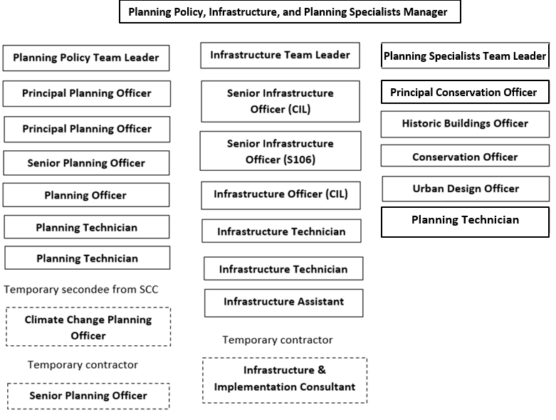
PERSON SPECIFICATION

Candidates must be able to demonstrate, giving examples, all essential criteria marked as A, A/C or A/I within their application form to be shortlisted for this role.

 | Person Specification
 | Essential criteria | How Assessed | Desirable criteria | How Assessed
Qualifications/ Education / Training / Experience | Educated to degree level in town planning, geography or other appropriate discipline | C | A management qualification (or evidence of recent managerial development). | C
Qualifications/ Education / Training / Experience | Membership or eligibility for membership of RTPI or other appropriate professional body | C
Qualifications/ Education / Training / Experience | Extensive experience in a senior role within planning policy. | A/I | Experience in leading and managing teams | A/I
Qualifications/ Education / Training / Experience | Experience of delivering innovative solutions in complex and demanding environments; requiring discretion, advocacy, persuasion skills and sensitivity combined with an ability to make balanced recommendations, often having extensive policy or service implications | A/I | A good understanding of the operation of Local Government, demonstrating a political awareness and the necessary skills to relate well to elected Members and work in a politically sensitive environment. | A/I
Knowledge /Technical Skills | Detailed knowledge of statutory planning law, policy and processes. | A/I
Knowledge /Technical Skills | Understanding of statutory basis for Community Infrastructure Levy and S106 contributions | A/I
Knowledge /Technical Skills | Ability to use Outlook, and Microsoft Office (Word, Excel, PowerPoint etc) | A | Experience of using Geographical Information Systems (GIS). | A
Knowledge /Technical Skills |  |  | Awareness of Safeguarding | A/I
Communication | Excellent communication and presentation skills both written and verbal | I/E
Communication | Political awareness and experience of presenting reports and giving advice to Councilors, including at committee meetings | I/E
Communication | Ability to work collaboratively in a multidisciplinary environment across the Council and with other key partners | A/I
Customer Service | Understanding of and commitment to promoting equality and diversity in service delivery and employment. | I | Experience of working in a customer facing and political environment with a clear focus on customer delivery and service improvement.
Customer Service | Accurate spoken English is essential for the post | I
Team Working | Motivate staff in a changing environment, encouraging empowerment - and ensuring effective decision making happens at the right level in the team | A/I
Team Working | A friendly and approachable manner with colleagues, member and customers | I
Managing self and others | Ability to prioritise and manage a complex workload | A/I
Managing self and others | Ability to delegate workflow effectively in a fast paced environment | A/I
Can do approach / Achieving results | Experience in target setting, performance management, and budgetary control | A/I
Can do approach / Achieving results | Relevant experience of project planning, managing and motivating a team of professional and technical staff or leading project teams/groups, carrying out work across a range of different activities | A/I
ADDITIONAL SPECIFIC REQUIREMENTS FOR THIS POST* | For business continuity purposes you are required to have access to the internet at home via broadband on a PC, laptop or tablet. | A
ADDITIONAL SPECIFIC REQUIREMENTS FOR THIS POST* | Full and valid driving licence | A
ADDITIONAL SPECIFIC REQUIREMENTS FOR THIS POST* | Attends site inspections  as required in the role and in accordance with the Business Travel Policy | A

* Please note that Waverley Borough Council cannot guarantee to supply you with the provision of equipment such as laptop, tablet, mobile phone or pool vehicle

How assesed:

A = Application CV/Personal Statement
C = Certificates/professional Registration
D = DBS police check
E = Exercise
I = Interview
M = Medical assessment

Politically Sensitive post: Political Restrictions
Please note that the Local Government Officers (Political Restrictions) Regulations 1990 apply to this post. In general terms these provisions mean that the postholder is prohibited from:
- holding or standing for elected public office (except Town or Parish Councils);
- holding office in a political party;
- speaking or writing in public (including on social media) in a personal capacity in a way that might be regarded as favouring one or other political party;
- canvassing at elections

For Official Use only
Job title: | Planning Policy, Infrastructure and Planning Specialists Manager | Post no:
Service: | Planning | JE score:
Team: | Planning Policy, Infrastructure and Planning Specialists | Pay band:
Location: | The Burys  Godalming,  Surrey GU7 1HR | Position type:  (if part time, working pattern) | Full time  37 Hours/ Five day week
Competencies:  (level 1 – 4) | Communication: | Add level
Competencies:  (level 1 – 4) | Customer Service:
Competencies:  (level 1 – 4) | Team Working:
Competencies:  (level 1 – 4) | Managing Self and Others: | Add level
Competencies:  (level 1 – 4) | Can do approach/Results:
Reviewed By: |  | Date:
Checked in: | HR | Date:
Last Updated: | Add date | Date:

