

Job Description: Housing Development Assistant

Waverley is an ambitious authority, committed to being one of the leading Councils in the country at a time of major change by developing a high performing, highly engaged staff team to share the organisation’s values and deliver our corporate objectives.

Job Description
Job title: | Housing Development Assistant
Service: | Regeneration and Economic Development
Team: | Housing Development Team
Location: | Hybrid
Reporting to: | Housing Development Manager
Responsible for: | N/A
Our Organisational Values
Collaboration   | We know, work with and support one another. We collaborate with residents, businesses and partners and realise the potential of the Guildford and Waverley Collaboration. We empower ourselves and others.
  Wellbeing | We look after our own and other’s wellbeing. We know it’s okay to talk to each other about anything we are struggling with. We stay resilient and raise any concerns we have.
Trusted   | We abide by the Nolan Principles of Public Life: Selflessness, Integrity, Objectivity, Accountability, Openness, Honesty, and Leadership.
Value for Money   | We spend public money wisely and carefully. We understand and follow our governance processes and raise any concerns with the right person. We celebrate successes and learn from mistakes.
Professionalism   | We provide professional advice and excellent service, we know our local areas and understand the communities we serve. We listen to all concerns and ideas. We benchmark our performance and always strive to improve.

Principal purpose of the role
To guarantee the provision of high-quality, efficient, and customer-oriented services that support the Housing Development Team.
Main duties and accountabilities
General Responsibilities:
With guidance and support, take responsibility for delivering minor projects to contribute to the successful execution of the Housing Development and Regeneration Programme.
Operational:
• Support the daily management and delivery of projects.
• Undertake minor housing development projects.
• Assist the Housing Development Manager in delivering a variety of new build and refurbishment projects.
• Receive void notifications, assess the potential for development, or determine appropriate use under license.
• Provide advice and assistance to customers via phone, email, or in person, diagnosing issues, offering tailored solutions, and coordinating with third parties to negotiate, gather information, and achieve satisfactory resolutions.
• Maintain a register to track planning conditions, update project risk logs, and monitor the project tracker for development initiatives.
• Collaborate with Asset Management to obtain information about existing stock and respond to inquiries related to new build properties after handover.
• Support Housing Development Officers in co-ordination of material needed as part of the handover process from contractor to Waverley Borough Council.
• In collaboration with the Housing Development Team, monitor jobs logged with Waverley Borough Council’s maintenance contractor and building contractors during the 12-month defects period.
• Lead on the resolution of identified latent defects, liaising with the relevant Housing Development Officer, contractor and tenant.
• Update void status on regeneration sites within the Housing Management System and ensure the accurate addition and updating of reference information throughout the defects period.
• Maintain effective central team office systems for easy access to information for the Housing Development Team.
• Compile reports for governance meetings and monitor project progress for reporting purposes.
• Under the direction of the Housing Development Manager and relevant Housing Development Officer, lead the organization of public relations events for new housing developments, including preparing promotional materials with the communications team, arranging venues, and inviting residents and guests.
• Support the Housing Development Team in preparing information for the marketing of shared ownership homes, arrange and meet prospective purchasers at the property.
• Participate in consultation activities with residents, especially for post-completion reviews and post-tenancy surveys.
• Assist the Housing Development Team in preparing information for grant funding applications and government returns
• Liaise with other Waverley Borough Council departments, external contractors, consultants, stakeholders, and the public as needed.
• Produce accurate, well-written notes, draft letters, newsletters and prepare mailshots using Microsoft Office and traditional or hybrid mail solutions.
• Work with the Development Officers, Website Manager and Communications team to update the housing development section on the Waverley Borough Council website and other communication platforms.
• Perform any other duties relevant to the role as required.
Finance and Budgets:
• Raise requisitions for purchase orders as necessary.
• Validate and process variations, payment applications, and invoices in a timely manner to ensure financial control.
Legal / Estates:
• Raise and monitor legal requests for the team.
• Maintain the contracts register in collaboration with the procurement, legal services and housing development teams.
• Log Freedom of Information Requests and monitor the timely responses to the legal team.
• Raise and track valuation requests for the team and ensure reports are saved centrally.
Business Continuity:
• Play a key role in business continuity planning and, if needed, assist in the recovery of key services within a 24-hour window.
Health and Safety:
• Comply with all relevant health and safety legislation, identifying, managing, and monitoring risks as required.

Dimensions of the role
- The post holder to be a member of a team of 6
- Member of a team responsible for the delivery of new build, mixed use and, regeneration programmes across the borough.
- Support preparation of papers for monthly/quarterly governance meetings
- Complete the assessment of sites following void notification / visits to sites c. 5 per month
Areas of Accountability/Problem Solving – Decision Making / Scope for Impact
- Assist with the day to day delivery of housing development projects.
- Ensure that tenants, particularly vulnerable tenants are supported efficiently and sensitively to meet the needs of the individual(s), sign posting where appropriate.
- Responsible for identifying sites with development potential from within the Council’s existing assets.
- Actively promote the Council’s Equality and Diversity Policy
- Ensure that the principle of confidentiality and the requirements of the Data Protection Act are fully applied
Planning/Organising/Controlling
- Be self motivated with the ability to effectively manage conflicting and changing priorities.
- Be accurate and process driven.
- Plan and prioritise individual workload to meet deadlines to meet personal and shared targets.
- Be effective in the use of systems available, such as Outlook to manage time and workloads.
- Contribute to service development and improvement planning and share ideas with line manager.
- Have a commitment to teamwork and internal communication.
Customers and Contacts
Internal
- Elected Members
- Other Departments within the Council, particularly housing, legal and financial services

External
- Tenants, residents, leaseholders and their representatives
- Tenants’ and residents’ groups
- Contractors, consultants and other service providers
- Surrey Police
- Members of the public
- Other statutory, voluntary and partner agencies

Service/Team Structure
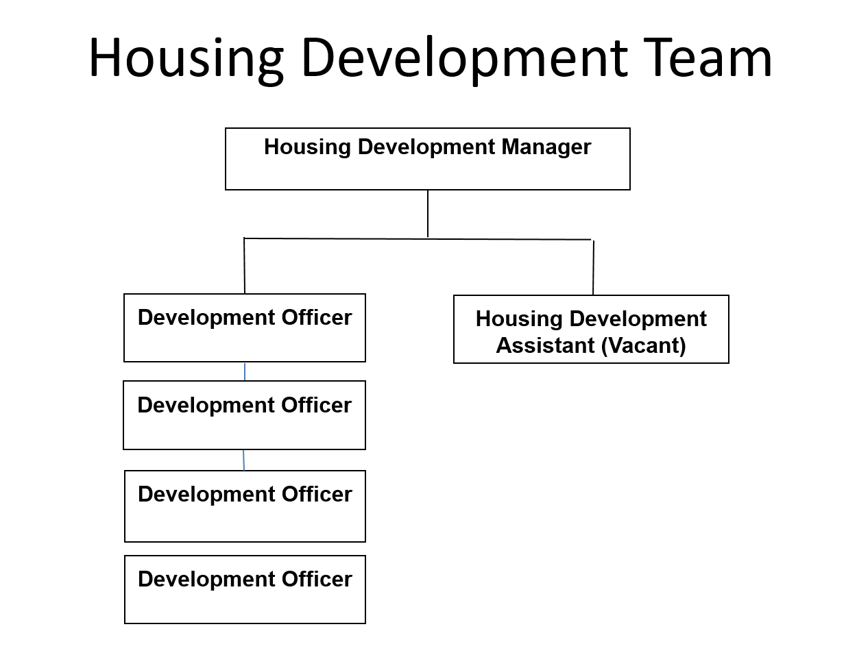

PERSON SPECIFICATION

Candidates must be able to demonstrate, giving examples, all essential criteria marked as A, A/C or A/I within their application form to be shortlisted for this role.

 | Person Specification
 | Essential criteria | How Assessed | Desirable criteria | How Assessed
Qualifications/ Education / Training / Experience | Well-developed IT skills with knowledge of Microsoft Office at intermediate level | A/I | Housing related qualification | A/I
Qualifications/ Education / Training / Experience | Willing and able to undertake further professional training and development | I | ECDL qualification | A/I/C
Qualifications/ Education / Training / Experience | Experience of working in social housing or a development, property or maintenance related environment | A/I | Working knowledge of Housing Development process from inception to completion within a local authority or similar organization | A/I
Qualifications/ Education / Training / Experience |  | A/I | Experience of carrying out consultation exercises | A/I
Qualifications/ Education / Training / Experience |  | A/I | Experience of the Homes England regulatory standards and systems | A/I
Qualifications/ Education / Training / Experience |  | A/I | Experience of social housing marketing and sales | A/I
Knowledge /Technical Skills | Track record of delivering excellent customer service even whilst working under pressure, with the ability to communicate effectively with both internal and external customers | I | Ability to process orders and invoices | A/I
Knowledge /Technical Skills | Ability to demonstrate an organized and systematic way of working with strong administration and record keeping | A/I | Ability to use mapping software e.g. Stat Map | A/I
Knowledge /Technical Skills |  |  | Awareness of Safeguarding | A/I
Communication | Ability to communicate clearly, and timely manner effectively. | I
Communication | Excellent written and oral communication skills, considering the needs of the audience when deciding how best to communicate. | A/I
Communication | Assertive, confident and self-assured when speaking to others | I
Communication | Ability to negotiate and influence others | A/I
Customer Service | Understanding of and commitment to promoting equality and diversity in service delivery and employment. | I
Customer Service | Accurate spoken English is essential for the post | I
Team Working | Flexible and adaptable | I
Team Working | Positively influence the way the team work together | A/I
Team Working | Deliver own share of workload, whilst being flexible and willing to help others when required | A/I
Team Working | Value the input, expertise and experience of others | I
Managing self and others | Produce high quality, accurate records, data and information | A/I
Managing self and others | Use effective time management techniques to meet agreed targets. | A/I
Can do approach / Achieving results | Ability to work on own initiative, but also be a team player | A/I
Can do approach / Achieving results | Ability to prioritise workload according to service requirements and remain calm when working to deadlines and or multiple tasks/deadlines. | A/I
ADDITIONAL SPECIFIC REQUIREMENTS FOR THIS POST* | For business continuity purposes you are required to have access to the internet at home via broadband on a PC, laptop or tablet. | A | Ability to work outside normal office hours | I
ADDITIONAL SPECIFIC REQUIREMENTS FOR THIS POST* | Full and valid driving licence

* Please note that Waverley Borough Council cannot guarantee to supply you with the provision of equipment such as laptop, tablet, mobile phone or pool vehicle

How assesed:

A = Application CV/Personal Statement
C = Certificates/professional Registration
D = DBS police check
E = Exercise
I = Interview
M = Medical assessment

Disclosure and Barring Service Check
Due to the nature of the work, this post involves a check on an individual’s criminal background. The check is carried out through the Disclosure and Barring Service (DBS, previously CRB). Any offer of employment will be subject to receiving satisfactory clearance from the Disclosure and Barring Service.

Basic Disclosure Clearance - Government Requirement for Accessing Council and Government Data
To comply with the Public Sector Networks (PSN) “Code of Connection”, Waverley Borough Council, like other public organisations, need to undertake basic disclosure checks for unspent convictions only, in respect of those staff who will access our IT systems.

For Official Use only
Job title: | Housing Development Assistant | Post no:
Service: | Housing Services | JE score:
Team: | Housing Development | Pay band:
Location: | The Burys  Godalming,  Surrey GU7 1HR | Position type:  (if part time, working pattern) | Full time  37 Hours/ Five day week
Competencies:  (level 1 – 4) | Communication: | 2
Competencies:  (level 1 – 4) | Customer Service: | 2
Competencies:  (level 1 – 4) | Team Working: | 2
Competencies:  (level 1 – 4) | Managing Self and Others: | 2
Competencies:  (level 1 – 4) | Can do approach/Results: | 2
Reviewed By: | Alanna Norman | Date:
Checked in: | HR | Date:
Last Updated: | 27.10.25 | Date:

