



Job Description: Lawyer (Planning)

Waverley and Guildford are ambitious authorities, committed to being two of the leading Councils in the country at a time of major change by developing high performing, highly engaged staff teams to share the organisation’s values and deliver our corporate objectives.

Job Description
Job title: | Lawyer (Planning)
Service: | Democracy, Law and People
Team: | Legal Services & Information Governance
Location: | The Burys, Godalming, Surrey, GU7 1HR and Millmead House, Guildford, GU2 4BB
Reporting to: | Principal Lawyer (Planning)
Responsible for: | Supporting Paralegal, Apprentices and Assistants
Our shared Organisational Values
Collaboration   | We know, work with and support one another. We collaborate with residents, businesses and partners and realise the potential of the Guildford and Waverley Collaboration. We empower ourselves and others.
  Wellbeing | We look after our own and other’s wellbeing. We know it’s okay to talk to each other about anything we are struggling with. We stay resilient and raise any concerns we have.
Trusted   | We abide by the Nolan Principles of Public Life: Selflessness, Integrity, Objectivity, Accountability, Openness, Honesty, and Leadership.
Value for Money   | We spend public money wisely and carefully. We understand and follow our governance processes and raise any concerns with the right person. We celebrate successes and learn from mistakes.
Professionalism   | We provide professional advice and excellent service, we know our local areas and understand the communities we serve. We listen to all concerns and ideas. We benchmark our performance and always strive to improve.

Principal purpose of the role
- To deliver high standards of legal advice and support to teams across the Councils, resolving planning legal matters as they arise.
- Ensure compliance with statutory regulations, legislation, professional codes of practice and adherence to Council policy.
- To deliver projects, interventions and initiatives in conjunction with teams across the Councils.
- To assist in the provision of a comprehensive legal service to the Councils, including the provision of high quality legal support, advice, assistance and transactional services to the Councils, its committees and officers at all levels.
- Covering all types of planning matters and other matters relating to the business of the Councils.
- The work may include contentious or non-contentious work depending on the individual’s practice area.

Main duties and accountabilities
- The provision of high quality and timely legal advice pertaining to a particular specialism and support to Officers and Members generally covering contentious and non-contentious matters according to practice area.
- To attend relevant Council Committees, working groups and briefings to give legal advice to Officers and Members, many of which will be held in the evening.
- To provide support to Senior Lawyers and Principal Lawyer in attending other such Committees or other meetings of Members and/or Officers and/or external parties as appropriate to practice area.
- Provide high quality and timely Planning law advice and support to Officers and Members generally.
- Support the preparation for the Council’s Joint and Area Planning Committees, working groups and briefings.
- Support preparation and execution of Enforcement Notices, Section 106 Agreements and other planning related documentation are drafted/approved to assist in ensuring that the Councils’ duties and responsibilities as Local Planning Authority are effectively discharged.
- Ensure the proper conduct of planning Inquiries, including the provision of advocacy at public hearings (by the postholder personally or the planning lawyer or by Counsel).
- Ensure the proper conduct of planning related litigation on behalf of the Council in the Civil and Criminal courts, including the provision of advocacy (by the postholder personally or by Counsel).
- To draft amend, advise upon, seek input from senior colleagues on and settle and complete all appropriate legal agreements, notices and other documents for concluding all planning matters.
- To give guidance and assistance to other member of the Legal Services Team as appropriate in respect of planning law matters.
- To provide high quality and timely legal advice in respect of other areas of the Council’s business as may be required by the Principal Lawyer, and in particular as they may relate to the Council’s Statutory functions (including those relating to but not limited to planning, property and contractual matters).
- To prepare all relevant cases for court, public inquiries or other hearings and represent the Council by carrying out the relevant advocacy or ensuring appropriate representation as appropriate to practice area.
- To instruct Counsel and external solicitors as appropriate and monitor their work and liaise with the Legal Services Practice Manager to ensure that all casework systems and documents storage is kept up to date.
- To draft amend, advise upon, settle and complete all appropriate legal agreements, notices and other documents for concluding all matters relevant to legal specialisms.
- To give guidance and assistance to other Legal Services colleagues as appropriate in respect of specialist legal experience.
- To maintain an up-to-date knowledge of the relevant areas of legislation and case law and advise on any implications for the work of the Council.
- To undertake necessary legal research as may be required and ensure that it is to an appropriate standard and advise accordingly, orally and in writing.
- To regularly input to Officer reports as appropriate to practice area and generally as required by the Head of Legal Services.
- To ensure that reports and correspondence prepared by others (for example, Legal Assistant, Solicitor Apprentice) are legally accurate.
- To provide regular progress updates on cases to Principal Lawyers and contribute positively as a member of the Legal Services team.
- To escalate matters to the Senior Lawyer, Principal Lawyer and Head of Legal Services as may be needed to ensure an excellent and time level of customer service is delivered.
- To carry out any other duties which may from time to time be required.
- To create and maintain authentic, timely and reliable records in relation to your duties. To take due care and attention when gathering, recording and manipulating data and to have regard to guidance issued by the Council in connection with data management.
- Carry a personal caseload of contentious and non-contentious work according to practice area.
- Undertake CPD to ensure that professional registrations can be kept current.
Business Continuity
- Play a pivotal role in business continuity planning and should the need arise assist in ensuring business recovery of key service provision in a 24 hour window.
- Health and Safety
Comply with all Health and safety legislation for your area of work, ensuring that risks are identified, managed and monitored as required

Dimensions of the role
- The work will consist of a varied caseload and the postholder will have regard to the relevant legislation and common law, corporate procedures, strategies, policies and powers, probity, Financial Regulations, the Constitution, Schemes of Delegation and other relevant issues.
- The post holder will be expected to obtain knowledge and experience of other areas of law other than their current specialism so as to enable additional capability and capacity to be built into Legal Services.
- The postholder can expect to deal with a caseload of up to 160 substantive matters per year in addition to regular ad hoc requests for legal advice on all types of matters on a day-to-day basis, some of which may require research.
- In addition to daytime meetings, the postholder will be required to attend and advise regularly at planning committees in the evenings during the year.
Areas of Accountability/Problem Solving – Decision Making / Scope for Impact
- The postholder will be accountable to a Principal Lawyer who will supervise their work.
- The postholder will be expected to take a high degree of responsibility for prioritising work and managing their caseload, identifying and discussing any issues as they arise and keeping work monitoring, filing and time recording records up to date.
- The postholder will be expected to work as a full member of the Legal Services Team, in co-operation with professional and other colleagues and will be required to advise or oversee junior members of the Legal Section on legal issues as appropriate to their specialist area of practice.
- The work may include major projects (and overseeing terms of external lawyers as required and directed), involving numerous legal complexities, where the postholder will represent the Principal Lawyer and/or Head of Legal Services and may serve as a member of a corporate team, attending meetings, etc.

Planning/Organising/Controlling
- The postholder will be required to be a clear and concise communicator, with an ability to communicate with, build and maintain trusted relationships with Officers at different levels in the Council.
- The postholder will be required to advise on matters with a variety of legal issues. This will require an ability to organise their workload independently, to prioritise those matters in order to support the officers concerned but also seek input and advice from senior colleagues appropriately.
- The postholder will be expected to provide advice in a professional manner in all situations.

Customers and Contacts
Internal
- Officers at different levels including Senior Officers and Members of the Council
External
- Subject to legal specialism and level of experience and capability, members of the legal and other professions, Court staff / Judges / Magistrates / other official personnel, Government Departments and their staff, members of the public. All types of outside organisations and their representatives.

Service/Team Structure
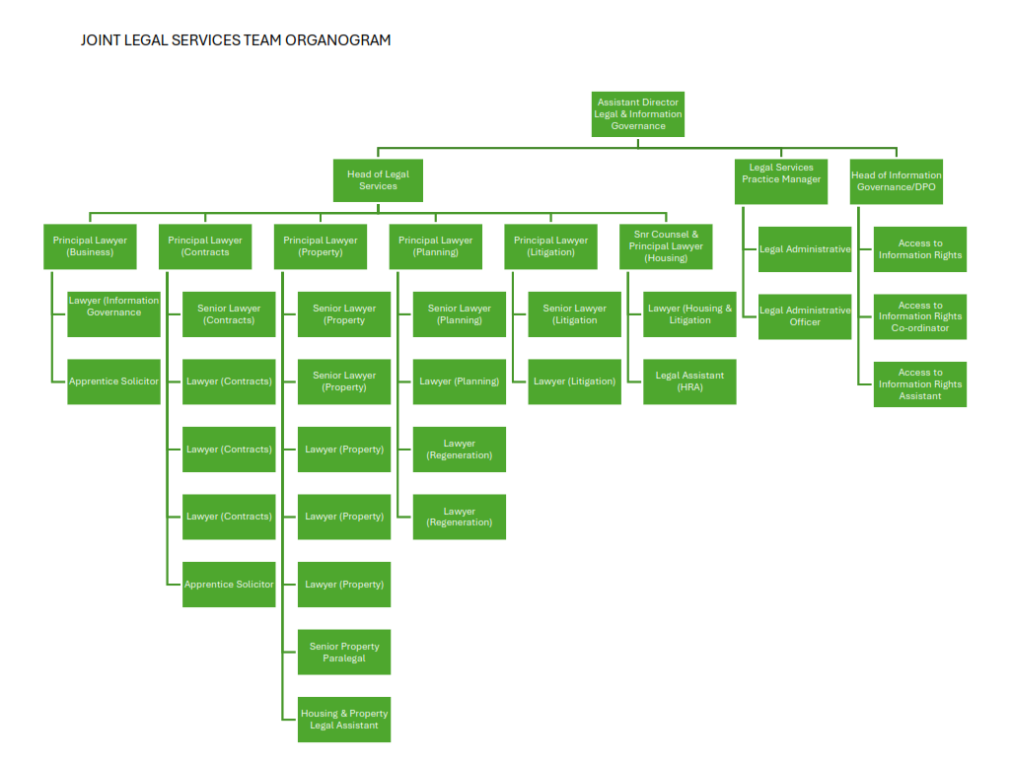

PERSON SPECIFICATION

Candidates must be able to demonstrate, giving examples, all essential criteria marked as A, A/C or A/I within their application form to be shortlisted for this role.

Person Specification
 | Essential criteria | How Assessed | Desirable criteria | How Assessed
Qualifications/ Education / Training / Experience | Qualified solicitor, barrister or legal executive with up-to-date practicing certificate or equivalent experience | A/I | Experience of advising at planning committee | A/I
Qualifications/ Education / Training / Experience | Experience of working in planning law | A/I
Knowledge /Technical Skills | Demonstrable working knowledge of the legal framework and obligations of local authorities, particularly in areas of specialist law. | A/I | Awareness of Safeguarding | A/I
Knowledge /Technical Skills | Demonstrable experience in drafting legal documentation. | A/I | Experience working in Local Government or equivalent organisation. | A/I
Communication | Able to communicate effectively with senior leaders as needed, regulatory bodies and other organisations, eg Courts in person/on the telephone/in writing in plain English rather than using jargon. | I
Communication | Demonstrable experience of negotiation skills in practice, particularly in contentious, complex Planning matters | A/I
Customer Service | Demonstrable experience of having provided high levels of customer service to client officers at all levels. | I
Customer Service | Ability to provide clear instructions to clients | I
Customer Service | Understanding of and commitment to supporting equality and diversity in service delivery and employment. | I
Team Working | Willing to take a high level of responsibility for a varied personal work load with conflicting priorities. | A/I | Willing to deal with various areas of the law other than those in which the postholder is a specialist. | A/I
Managing self and others | Able to work effectively to deadlines and escalate appropriately if deadlines are under pressure. | A/I | Significant experience of supporting the setting of strategic direction and providing ongoing leadership of the service to achieve service plan objectives. | A/I
Managing self and others | Able to independently manage their own caseload seeking support where needed and while delivering high quality legal advice. | A/I
Can do approach / Achieving results | A positive contributor to a team. | I
Can do approach / Achieving results | Willing to support other team members in order to complete tasks and to deliver the service. | I
Additional Specific Requirements for this Post* | For business continuity purposes you are required to have access to the internet at home via broadband on a PC, laptop or tablet. | A
Additional Specific Requirements for this Post* | Able to attend evening meetings. | A

How assesed:

A = Application CV/Personal Statement
C = Certificates/professional Registration
D = DBS police check
E = Exercise
I = Interview
M = Medical assessment

Politically Sensitive post: Political Restrictions
Please note that the Local Government Officers (Political Restrictions) Regulations 1990 apply to this post. In general terms these provisions mean that the postholder is prohibited from:
• holding or standing for elected public office (except Town or Parish Councils);
• holding office in a political party;
• speaking or writing in public (including on social media) in a personal capacity in a way that might be regarded as favouring one or other political party;
• canvassing at elections

Behavioural competencies:

COMPETENCIES  (LEVEL 1 – 4) | Communication: | 2
COMPETENCIES  (LEVEL 1 – 4) | Customer Service: | 2
COMPETENCIES  (LEVEL 1 – 4) | Team Working: | 3
COMPETENCIES  (LEVEL 1 – 4) | Managing Self and Others: | 2
COMPETENCIES  (LEVEL 1 – 4) | Can do approach/Results: | 2
Reviewed By: |  | Date:
Checked in: | HR | Date:
Last Updated: | Claire Beesly | Date: | May 2025
For Official Use only
Job title: | Lawyer (Planning) | Post no:
Service: | Democracy, Law and People | JE score:
Team: | Legal Services | Pay band: | 5
Location: | The Burys, Godalming, GU7 1HR and Millmead House, Guildford, GU2 4BB | Position type:  (if part time, working pattern) | Part Time  29.5 hours

