
Job Description:

Housing Operations Support Officer
Waverley is an ambitious authority, committed to being one of the leading Councils in the country at a time of major change by developing a high performing, highly engaged staff team to share the organisation’s values and deliver our corporate objectives.

Job Description
Job title: | Housing Operations Support Officer
Service: | Housing Operations.
Team: | Property Services
Location: | The Burys, Godalming, Surrey, GU7 1HR
Reporting to: | Housing Operations Support Manager
Responsible for: | Not Applicable
Our Organisational Values
Collaboration   | We know, work with and support one another. We collaborate with residents, businesses and partners and realise the potential of the Guildford and Waverley Collaboration. We empower ourselves and others.
Wellbeing   | We look after our own and other’s wellbeing. We know it’s okay to talk to each other about anything we are struggling with. We stay resilient and raise any concerns we have.
Trusted   | We abide by the Nolan Principles of Public Life: Selflessness, Integrity, Objectivity, Accountability, Openness, Honesty, and Leadership.
  Value for Money | We spend public money wisely and carefully. We understand and follow our governance processes and raise any concerns with the right person. We celebrate successes and learn from mistakes.
  Professionalism | We provide professional advice and excellent service, we know our local areas and understand the communities we serve.We listen to all concerns and ideas. We benchmark our performance and always strive to improve.
Principal purpose of the role
- Delivery of excellent service to all customers in line with published service standards, including provision of advice and assistance to all customers.
- Support collaborative and cross functional working, sharing resources across the team and the wider Housing Service to meet operational targets and priorities.
- Equality and Diversity – Actively promote the Council’s Equality and Diversity
policy in all aspects of your duties.

- Safeguarding – Adhere to effective safeguarding practice for vulnerable adults and children in accordance with the Council’s policies, guidance and protocol.
- Dignity and Respect – Treat all colleagues with dignity and respect whilst at work so that they are encouraged to meet their full potential by working in a non- threatening environment free of harassment and/or bullying.
Main duties and accountabilities
Operational
- Responsible for the delivery of high quality, effective admin tasks and service provision in support of the Property Services Team within Housing Operations. Primary Focus: Responsive Repairs, Planned Works, Community Estates & Development.
- To deal efficiently with telephone calls & a plethora of broad ranging correspondence relating to Property Services, ensuring an efficient service is maintained whilst adhering to specific policies and procedures.
- Understand, maintain, and operate computer systems, including Orchard, Agresso, Keystone, SharePoint, Case Management, Civica & Microsoft office suite.
- To maintain accurate records, collating & recording relevant information regards to the subject matter
- To provide administration support to the Planned Maintenance Team, Community estates & development & Responsive repairs Team in respect of communicating with our residents, contractors, resident focus groups, members of the public, councilors and MPs guaranteeing a timely answer to all enquiries.
- Assist in providing support to residents and team members in the delivery of all associated work streams for the Planned Works team (To provide administrative support to the Planned Works Officers, including raising works orders, mail merges, correspondence, Monthly Contractor Meeting minutes and general administrative duties)
- To provide administrative support to the Community Estates & development team, in respect of raising works orders on Orchard, administering the Block Safety Tracker, responding to the HOST inbox and supporting the Tenant Alterations requests ensuring the customer receives prompt and complete responses to their enquiry and a record of actions logged accordingly.
- To provide administrative support to the HOST Manager

Customer Service
- Delivery of excellent service to all customers in line with published service standards, including provision of advice and assistance to all customers. Ensuring the customer receives a prompt and complete response to their enquiry and an accurate record of actions recorded.
- Treat all customers, contractors and contacts with dignity and respect whilst at work in accordance with the Council’s policies, guidance and protocols.
- Ensure that the principle of confidentiality and the requirements of the Data Protection Action are fully applied at all times.
- Actively promote the Council’s Equality and Diversity policy in all aspects of your duties.

Finance & Budgets
- Identification of recharge cases and liaison with Recharge Officer to enable appropriate valuation and invoice production.

Business Continuity
- Play a pivotal role in business continuity planning in ensuring business recovery of key service provision in a 24 hour window

Team Working & Communication
- Provide service specific advice and support to colleagues in Housing Operations and across the Council.
- Attend and contribute to all meetings as requested.

Training and Development
- Undertaking training and development opportunities as required to ensure that the available skills are in place to meet business objectives and enable the achievement of potential.

Service Development & Improvement
- Contribute to service development and improvement planning and share ideas with your Line Manager.

Health & Safety
- Comply with all the Health & Safety legislation for your area of work, ensuring that risks are identified, managed and monitored as required.
- Ensure compliance with the Council’s Asbestos policies are procedures are adhered to too.

Dimensions of the role
- Properties – 5,000
- Work Orders Raised – 30,000 per annum
- Pre Inspections Raised – 2,000 per annum
- Number of Intervention cases: c. 120 per annum

- Number of tenancy audits: c. 720 per annum
- Number of partnership meetings: c. 75 per annum

Areas of Accountability/Problem Solving – Decision Making / Scope for Impact
- Ability to deal with a broad customer spectrum
- Taking appropriate ownership of customer queries to overseeing them until resolution.
Escalation of issues in relation to the safeguarding of vulnerable adults to the appropriate authorities both internally and externally.
- Diagnosis and analysis of incoming calls to determine appropriate course of action
- Diagnosis of repair requirements in order to select accurate schedule of rates codes to ensure accurately costed orders are raised.
- Maintaining a clean database
Planning/Organising/Controlling
- Issuing work orders, allocation of appointments and relevant inspections visits
- Production of job orders dispatched to relevant contractor.
- Checking invoices for accuracy and processing within Orchard to agreed timescales.
- Processing invoice payments through accounting system Agresso to ensure prompt payment
- Batching, indexing and storage of documents within Civica
- Recording and reporting of complaints received to relevant parties to agreed timescales.
Customers and Contacts
Internal
- All staff including the Corporate Management Team, Executive members including portfolio holders for the Housing Services & ward members.
External
- Tenants, leaseholders, tenant resident groups, members of the public,
contractors, suppliers, utility companies, citizens advice bureau, Police, Support Workers & Social Services.

Service/Team Structure
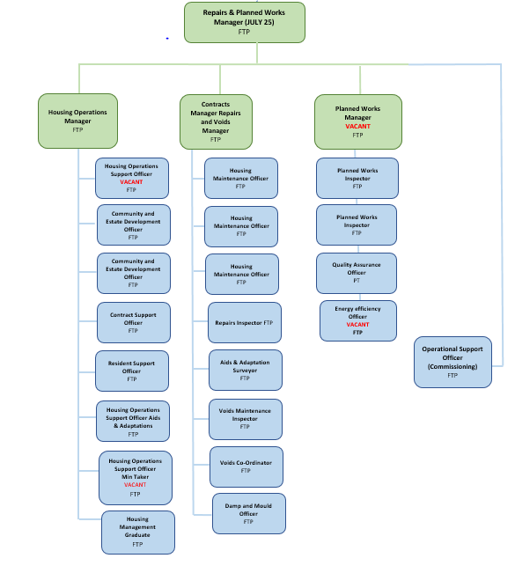

PERSON SPECIFICATION

Candidates must be able to fully demonstrate all essential criteria within their application form to be shortlisted for this role.

Person Specification
 | Essential criteria | Desirable criteria
Qualifications/ Education / Training / Experience | - A good general standard of education at GCSE or equivalent including English & Math’s  - Computer Literacy | - European Computer Driving License (ECDL) or equivalent.
Knowledge  /Technical Skills | - Experience of working with customers via telephone, email, letter or face to face with a fast paced and dynamic customer centric environment.  - Ability to keep accurate records of all essential information.  - Understanding of safeguarding practices and requirements | - Upkeep – City & Guilds Certificate in Diagnosing Defects & Ordering Repairs  - Awareness of asbestos to UKATA standards  - Ability to diagnose basic housing repairs relation to plumbing, electrical and general building works  - Knowledge or experience of dealing with vulnerable people
Communication | - Ability to choose the most effective communication method dependent on the situation and individual requirements  - Demonstrate experience of using active listening skills.  - Demonstrate experience of actively ensuring stakeholders are kept informed to manage expectations  - Ability to communicate and provide advice in accurate spoken English
Customer Service | - Understanding of and commitment to promoting equality and diversity in service delivery and employment.  - Exhibit ability to identify and meet customer needs and expectations  - Display ability of taking ownership of customer | - Contribution of ideas to improve Customer Service

requests, manage expectations in order to achieve a high quality resolution
- Experience of dealing with needs diverse customer base
Team Working | - Ability to use resources efficiently in order to achieve goals and targets.  - Demonstrate a willingness to learn from others | - Experience of positively influencing the way a team works together
Managing self and others | - Experience of achieving objectives on time and accurately
Can do approach  / Achieving results | - Demonstrate experience of using initiative with successful outcomes | - Display ability to constructively challenge practices in order to achieve performance improvement.
Special Requirements | - For business continuity purposes you are required to have access to the internet at home via broadband on a PC, laptop or tablet.

For Official Use only
Job title: | Housing Operations Support officer | Post no:
Service: | Housing Operations | JE score: | 204
Team: | Property Services | Pay band: | 9
Location: | The Burys Godalming,  Surrey GU7 1HR | Position type:  (if part time, working pattern) | Full time  37 Hours/ Five day week
Competencies: (level 1 – 4) | Communication: | 2
Competencies: (level 1 – 4) | Customer Service: | 2
Competencies: (level 1 – 4) | Team Working: | 2
Competencies: (level 1 – 4) | Managing Self and  Others: | 2
Competencies: (level 1 – 4) | Can do  approach/Results | 2
Reviewed By: | Matt Alexander | Date: | 24/04/2023
Approved By: | Human Resource | Date: | 24/04/2023
Last Updated: | Human Resources | Date: | 24/04/2023

