

Waverley is an ambitious authority, committed to being one of the leading Councils in the country at a time of major change by developing a high performing, highly engaged staff team to share the organisation’s values and deliver our corporate objectives.

Job Description
Job title: | Principal Planning Officer (Policy)
Service: | Planning
Team: | Planning Policy, Infrastructure and Planning Specialists (PIPPS)
Location: | The Burys, Godalming, Surrey, GU7 1HR
Reporting to: | Planning Policy Team Leader
Responsible for: | Line management responsibilities supporting other members of the Planning Policy team.
Our Organisational Values
Collaboration   |  | We know, work with and support one another. We collaborate with residents, businesses and partners and realise the potential of the Guildford and Waverley Collaboration. We empower ourselves and others.
  Wellbeing |  | We look after our own and other’s wellbeing. We know it’s okay to talk to each other about anything we are struggling with. We stay resilient and raise any concerns we have.
Trusted   |  | We abide by the Nolan Principles of Public Life: Selflessness, Integrity, Objectivity, Accountability, Openness, Honesty, and Leadership.
Value for Money   |  | We spend public money wisely and carefully. We understand and follow our governance processes and raise any concerns with the right person. We celebrate successes and learn from mistakes.
Professionalism   |  | We provide professional advice and excellent service, we know our local areas and understand the communities we serve. We listen to all concerns and ideas. We benchmark our performance and always strive to improve.
Principal purpose of the role
- To assist in the preparation, examination, delivery and review of the Local Plan.

- To assist in the preparation and review of other planning policy related documents and planning guidance for specific sites.

- To help to ensure that the planning policy framework for the Borough reflects best practice and remains up to date and effective.

- To assist the PIPPS Manager and the Joint Assistant Director of Planning in achieving Council and departmental objectives and targets.

- To provide support and advice to town and parish councils preparing neighbourhood plans and neighbourhood development orders.

Main duties and accountabilities
- To carry out and, where necessary, supervise work on the production of the Local Plan, including taking the lead on specific topics, as may be required, ensuring that deadlines are met and consultations carried out in accordance with the Statement of Community Involvement.
- To contribute to the production and review of supplementary planning documents, development briefs and strategies to promote and guide beneficial development on sites of major significance within the Borough.
- To provide timely responses to consultations on planning policy matters and new documents.
- Provide advice and assistance relating to the preparation of neighbourhood plans and neighbourhood development orders, including attending meetings as the Borough Council’s representative; advising on and, where required, coordinating the preparation of appropriate studies and technical work; advising other council officers and members and town and parish councils on securing grant funding for neighbourhood planning and representing the Borough Council as its expert witness on neighbourhood plans at examinations, public inquiries and other meetings.
- To attend Committee meetings, Working Parties and other meetings as required and represent the Council at Local Plan examinations and planning appeal inquiries and hearings
- To liaise with Government Departments, Surrey County Council, Town and Parish Councils, amenity societies, public utilities and other stakeholders and represent the Borough Council.
- To provide timely responses to consultations on planning policy matters and new documents
- Some line management responsibilities supporting other members of the Planning policy Team.
- To embrace the broader role that spatial planning has in terms of delivery and ensuring that the development of new planning policies is aligned with the plans and strategies of other key service providers.
- To keep abreast of national and local policies and community needs to ensure that the planning process can deliver the appropriate outputs and outcomes.
- Business Continuity
- Play a pivotal role in business continuity planning and should the need arise assist in ensuring business recovery of key service provision in a 24 hour window.
- Health and Safety
Comply with all Health and safety legislation for your area of work, ensuring that risks are identified, managed and monitored as required

Dimensions of the role
- Agile Working. Attendance in the office, based in Council Offices at Godalming, dependent on the current operational needs of the Service.
- Required to attend meetings and site visits in Waverley and, occasionally, elsewhere.
- Some out of hours attendance at meetings, exhibitions etc. as necessary.
- Line management responsibilities supporting other members of the Planning Policy Team.
Areas of Accountability/Problem Solving – Decision Making / Scope for Impact
- The postholder will have key role in supporting the production of the new Local Plan for Waverley and other supporting documents. There will be wide scope for shaping the development of planning policy and how it impacts on the community.
- Advising Town and Parish Councils, Council members and officers and other organisations of the procedures for preparing neighbourhood plans and neighbourhood development orders in accordance with the legislation.
Planning/Organising/Controlling
- The postholder would be actively involved in the engagement of the community in relation to the Local Plan, development briefs etc. and would play a role in communicating with the local community and other interested parties.
- Playing a senior role within the Planning Policy Team, including taking the lead on specific projects and supervising the work of other members of the Team and advising internal colleagues and external stakeholders
Customers and Contacts
Internal
- All Planning Service staff, all other Council services, Council Members
External
- Town and Parish Councils, Surrey County Council, other local authorities, other organisations, the development industry, business organisations, amenity and special interest groups, Government Departments, regional organisations, members of the public, amenity and special interest groups

Service/Team Structure
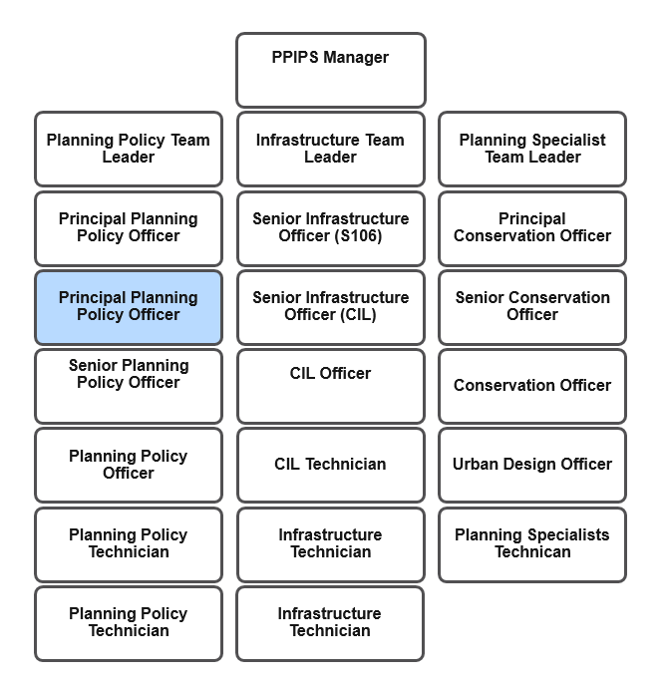

PERSON SPECIFICATION

Candidates must be able to demonstrate, giving examples, all essential criteria marked as A, A/C or A/I within their application form to be shortlisted for this role.

 | Person Specification
 | Essential criteria | How Assessed | Desirable criteria | How Assessed
Qualifications/ Education / Training / Experience | Full Chartered Membership of the Royal Town Planning Institute (RTPI) or achievement of Chartered Membership by the end of the probationary period. | A/C | Additional relevant qualifications (such as those linked to planning or qualifications in Project Management) | A/C
Qualifications/ Education / Training / Experience | Degree in Planning or a related subject | A/C | Management training | A/C
Knowledge /Technical Skills | Significant knowledge of planning practice | A/I/E | Considerable experience of preparing and assessing planning policies, including managing specific planning policy projects | A/I
Knowledge /Technical Skills | Full understanding and knowledge of the legislation, procedures, and guidance relating to planning policy matters | A/I/E | Project Management experience | A/I
Knowledge /Technical Skills | Competent in the use of IT applications including mapping software, word processing, spreadsheets and databases. | A/I | Awareness of Safeguarding | I
Knowledge /Technical Skills | Demonstrate competence in dealing with complex planning issues | A/I | Experience in advising and assisting parish/town councils on neighbourhood planning. | I
Communication | Ability to communicate effectively, in writing and orally, with a wide range of individuals and organisations. | A/I/E | Experience in community engagement on specific projects | I
Communication | Effective negotiator | I
Customer Service | Understanding of and commitment to promoting equality and diversity in service delivery and employment. | I
Customer Service | Commitment to providing good customer care | A/I
Customer Service | Accurate spoken English | I/E
Customer Service | Evidence of working effectively within a political environment | A/I
Team Working | Team player willing to make a full contribution to the varied workload of the team.  | A/I | Leadership skills | A/I
Team Working |  |  | Facilitiation skills | A/I
Managing self and others | Good organisational and time management skills | A/I | Experience in managing and supervising staff effectively. | A/I
Managing self and others | Ability to work under pressure with the minimum of supervision | A/I
Can do approach / Achieving results | Determination, drive and enthusiasm to see projects through to a successful conclusion | A/I
Can do approach / Achieving results | Outward looking with an appreciation of the impact of planning on the external environment | A/I
Special Requirements | For business continuity purposes you are required to have access to the internet at home via broadband on a PC, laptop or tablet. | A
Special Requirements | Full and valid driving licence. | A/C
Special Requirements | Able to carry out site visits as required in the role in accordance with the Business Travel Policy, and attend occasional evening and weekend meetings/events | A/I

How assessed
A = Application CV/Personal Statement
C = Certificates/professional Registration
D = DBS police check
E = Exercise
I = Interview
M = Medical assessment

For Official Use only
Job title: | Principal Planning Officer (Policy) | Post no: | CD04
Service: | Planning | JE score: | 427
Team: | Planning Policy | Pay band: | P5
Location: | The Burys  Godalming,  Surrey GU7 1HR | Position type:  (if part time, working pattern) | Full time  37 Hours/ Five day week
Competencies:  (level 1 – 4) | Communication: | 3
Competencies:  (level 1 – 4) | Customer Service: | 3
Competencies:  (level 1 – 4) | Team Working: | 3
Competencies:  (level 1 – 4) | Managing Self and Others: | 3
Competencies:  (level 1 – 4) | Can do approach/Results | 3
Reviewed By: | Planning Policy Team Leader | Date: | 1st April 2025
Checked in: |  | Date:
Last Updated: |  | Date:

