


Job Description
Job title: | Adaptations Surveyor
Service and team: | Community Services, Grants & Adaptations Team
Band:  Post number: | 6  P10559
Reporting to: | Interim Grants & Adaptations Manager
Responsible for: | N/A
Our Organisational Values
Collaboration   | We know, work with and support one another.
Wellbeing   | We look after our own and others’ wellbeing.
Trusted   | We abide by the Nolan principles of public life.
Value for Money   | We spend public money wisely and carefully.
Professionalism   | We provide professional advice and excellent service, we know our local areas and understand the communities we serve.
Principal purpose of the team and role
- Team – Delivering the Council’s Adaptation programme to elderly, vulnerable and disabled council tenants
- Role - To offer advice and support to clients seeking assistance in all technical aspects of carrying out improvement and adaptation work to their Council owned homes across Guildford
Areas of Accountability
- Providing advice, guidance and coaching in technical building related areas to managers and non-technical colleagues, in order to help achieve the corporate goals of the Council
Main duties and responsibilities
- To provide a client-led technical service for elderly, disabled and vulnerable clients seeking to access to the Adaptations service in the public sector.
- To provide advice on the eligibility criteria for funding works to GBC tenanted homes
- To carry out detailed feasibility surveys for property adaptations required to meet the client’s needs
- To take measurements and prepare schedules, costing, plans and specifications, and ensuring the feasibility of schemes, estimates, plans and works comply with legislation, Government circulars, statutory regulations, and Guildford Borough Council policy and audit requirements
- To tender specifications to contractors and evaluate estimates upon receipt
- To arrange start dates and supervise works on site to ensure progress and quality of work
- To fulfil the role of the Joint Contracts Tribunal Contract Administrator
- To inspect works on site, make valuations for interim payments and complete certificates for the amount of monies to be paid, and agree additional work (where appropriate) and assess and certify final accounts
- To act on behalf of clients in disputes with contractors and mediate where possible over defects of workmanship or materials used during the defects liability period
- To monitor contract KPI’s and contribute to contract review meetings
- To make applications for planning consent and building regulation approval where necessary, ensuring that all work complies with building regulations and planning, and Health and Safety legislation
- To prepare reports, conduct correspondence and maintain both written and computerised records relating to work which includes the preparation and maintenance of adaptation information and costs, including computerised systems
- To maintain a comprehensive working knowledge of relevant legislation, codes of practice, circulars, policies and technical developments
- To respond flexibly to the changes in work arising from legislative development, customer needs and service reviews, and to routinely assist with tasks associated with service improvement
- To respond to all customer care standards within the targets set by the unit, including keeping customers regularly informed
- To take the lead on resolving complaints and problems of a technical nature and devise and oversee solutions to reach a satisfactory conclusion for customers, contractors and carers
- To keep up-to-date with individual training needs and the team’s training needs on technical issues and to determine the most suitable training method for the individual
Dimensions of the team role
- The team has an annual budget of £650,000 (under review to be increased) for major and minor adaptations
- Around 200 major and minor adaptations are completed each year
- The team work closely with Surrey County Council Adult Social Care Team and the Children with Disabilities Team and colleagues in the NHS
Customers and Contacts
Internal
- Officers at all levels in the service
- Housing colleagues
- Planning and Building Control officers
- Procurement and Legal officers
- Occupational therapists and Bathing Advisor
- Elected members
External
- Members of the public
- Officers of Surrey County Council social services
- NHS staff
- GPs
- OT contractors
- Consultant Architects/Surveyors
- Building Contractors
- Voluntary organisations
- Client advocates
Service/Team Structure
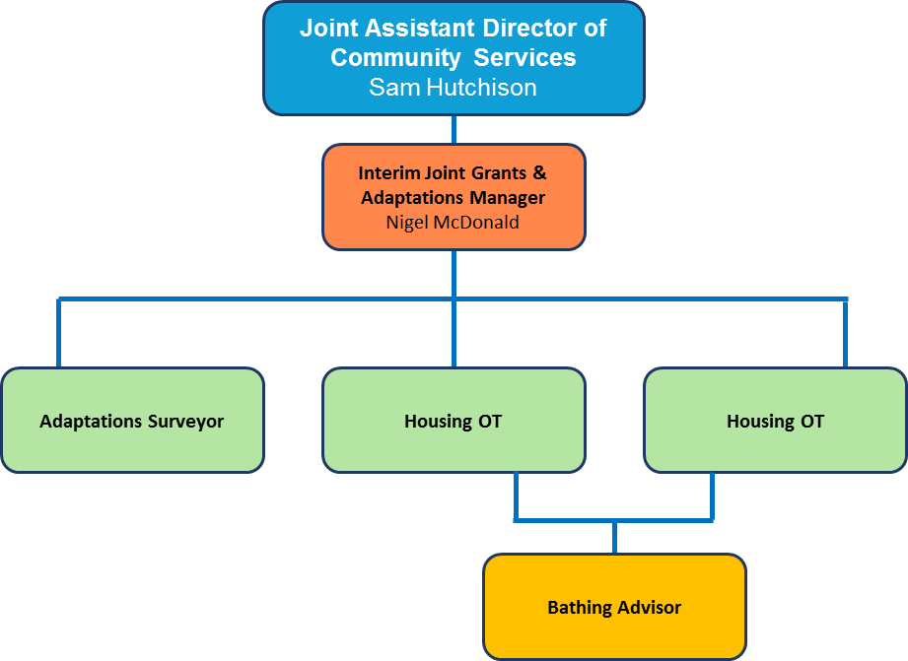

PERSON SPECIFICATION
Candidates must be able to demonstrate, giving examples, all essential criteria marked as A, A/C or A/I within their application form to be shortlisted for this role.

How assessed
A = Application CV/Personal Statement
C = Certificates/professional Registration
D = DBS police check
E = Exercise
I = Interview
M = Medical assessment

 | Essential criteria | How Assessed | Desirable criteria | How Assessed
Qualifications | Holder of a relevant surveying, building or construction related qualification, e.g. BTEC, HND, CIOB, RICS |  |  | A  I  C
Knowledge | - Knowledge of improvements and adaptations in residential properties in a technical capacity  - A thorough knowledge of building construction, technology and building practice regarding repair and adaptation of residential premises  - Knowledge of current building prices and the ability to accurately assess reasonable cost of proposed renovation work to dwellings, and the value of the work carried out  - Knowledge of computer packages, such as Microsoft Word, Excel and Outlook or similar to record progress and provide analytical data  - Knowledge of assessing defects and remedies in residential properties  - Knowledge of the current building regulations with particular regard to Part M  - Knowledge of CDM and Health & Safety Principles |  | - Knowledge of Orchard and Idox databases | A  I
Experience | - Experience of programming, negotiating and supervising building contracts  - Experience of working with contractors, dealing with disputes and negotiating good outcomes  - Experience of inspecting and surveying dwellings and preparing detailed specifications of work  - Experience of managing a large geographical area and organising a fluctuating workload |  | - Experience of working in the adaptations sector, supporting elderly, disabled and vulnerable clients to make good decisions, and understanding their needs  - Experience of working with occupational therapists and other related health professionals, including explaining technical building matters in a way that can be understood | A I
Skills
Technical skills |  |  | Ability to draw up and interpret scale plans, schemes of work and costing, in relation to residential properties using Computer Aided Design (CAD) or similar methods | A  I
Communication skills | - Ability to communicate effectively with other members of staff, councillors, customers and a wide range of organisations.  - Produces high quality written and verbal communication |  |  | A  I
Team Working skills | - Builds constructive and productive internal and external relationships  - Is committed to continually improving team performance  - Supports learning and development  - Encourages the team to succeed |  |  | A  I
Customer Service skills | - Demonstrates an understanding of Equalities and Customer Care and its importance in both employment and service delivery  - Invites customer feedback |  |  | A  I
Organisational skills | - Ability to prioritise own workload and ensure effective service delivery  - Stays calm and focused under pressure |  |  | A  I
ADDITIONAL SPECIFIC REQUIREMENTS FOR THIS POST | - Driving license valid to drive in the UK |  |  | A

Behavioural competencies

This section details the level of competency required to carry out this role (please see below for an overview of the framework and refer to the full Organisational Culture Framework - Guildford Borough Council Intranet for clarification where needed). | Level
Embraces change | 2
Innovation and creative thinking | 2
Effective communication | 2
Customer focus | 3
Problem solving and decision making | 3
Focus on efficiency | 3
Performance and learning | 3
Team working | 3
Builds relationships | 3
Commitment to the organisation | 2

Due to the nature of the work, this post involves a check on an individual’s criminal background. The check is carried out through the Disclosure and Barring Service. Any offer of employment will be subject to receiving satisfactory clearance from the Disclosure and Barring Service.
Reviewed By: |  | Date:
Checked in: |  | Date:
Last Updated: |  | Date:

 | Guildford Borough Council Behavioural Competencies
Cluster | Transformation  Forward looking. The focus on our ability to respond to ever changing needs of our customers and bring about new ideas to ensure value for money. |  | Delivering excellence  Efficiently run. The focus on the values and behaviours (in addition to internal systems) that ensures efficiency and effectiveness at every level across the Council. |  | Our people  To ensure that individuals at all levels of the organisation are supported, committed and engaged in the pursuit of our mission and work in a collaborative manner to fulfil our objectives.
Values | Challenge ourselves  We strive to improve what we do by seeking out new ways of working, encouraging innovation and enabling change. |  | Customer care  We put the customer at the heart of what we do by engaging in clear, honest, and meaningful communications to deliver professional services shaped around their needs. | Quality focus  With customer insight, we provide high-quality services and find ways to improve. We aim to get things right first time, drive out waste and exceed expectations whenever possible. | Organisational learning  We strive to create a work environment where everyone is valued, trusted, and supported. We encourage and facilitate growth and learning at individual, team, and organisational levels. | One Council  We work together collaboratively, recognising that we are one organisation, working to achieve a common mission.
Behavioural competencies | Embraces change  Has a positive attitude to change, adapts to meet new challenges, and introduces changes to improve organisational performance. | Innovation and creative thinking  Proactively generates and develops innovative ideas, opportunities or improvements in order to meet organisational objectives more efficiently and effectively. | Customer focus  Puts the customer first, builds effective relationships and seeks feedback to address their needs. | Problem solving and decision making  Understands and analyses issues in order to identify the most appropriate solutions. Makes effective decisions based on thorough analysis and the needs of the organisation. | Performance and learning  Demonstrates personal commitment to meet agreed performance standards and objectives. Learns from experience and takes responsibility for identifying and addressing personal development needs. | Team working  Proactively cooperates and interacts with colleagues, internal and external partners across the Council. Encourages others to develop a collaborative approach to share information, knowledge, and ideas.
Behavioural competencies | Effective communication  Communicates effectively. Uses communication methods and standards, together with well-reasoned arguments to convince and persuade where necessary. |  | Focus on efficiency  Meets or exceeds the Council’s standards by monitoring the quality of own work, team or service delivery. Continually looks for areas of improvement to ensure efficiency, effectiveness, and value for money. |  | Builds relationships  Presents a professional image; uses interpersonal skills to form positive and productive working relationships within and beyond the organisation. | Commitment to the organisation  Consistently supports and demonstrates an understanding of and commitment to the Council’s vision and values. Acts with integrity and accountability.

This page is left intentionally blank

