

Job Description: Tenancy Audit Officer

Waverley is an ambitious authority, committed to being one of the leading Councils in the country at a time of major change by developing a high performing, highly engaged staff team to share the organisation’s values and deliver our corporate objectives.

Job Description
Job title: | Tenancy Audit Officer
Service: | Housing Operations
Team: | Housing Management
Location: | The Burys, Godalming, Surrey, GU7 1HR
Reporting to: | Housing Manager
Responsible for: | N/A
Our Organisational Values
Collaboration   | We know, work with and support one another. We collaborate with residents, businesses and partners and realise the potential of the Guildford and Waverley Collaboration. We empower ourselves and others.
  Wellbeing | We look after our own and other’s wellbeing. We know it’s okay to talk to each other about anything we are struggling with. We stay resilient and raise any concerns we have.
Trusted   | We abide by the Nolan Principles of Public Life: Selflessness, Integrity, Objectivity, Accountability, Openness, Honesty, and Leadership.
Value for Money   | We spend public money wisely and carefully. We understand and follow our governance processes and raise any concerns with the right person. We celebrate successes and learn from mistakes.
Professionalism   | We provide professional advice and excellent service, we know our local areas and understand the communities we serve. We listen to all concerns and ideas. We benchmark our performance and always strive to improve.

Principal purpose of the role
- To deliver a patch-based Tenancy Audit service ensuring that WBC have full and current details of tenants and properties.
- To provide further insight into tenancy status and property conditions and tenants personal details.
- To work in partnership with Housing Officers to effectively support the most vulnerable tenants to manage their tenancies.

Main duties and accountabilities
- To carry out home visits to complete tenancy audit questionnaires
- To carry out visual property inspections
- To identify support for tenants where appropriate in order for them to sustain their tenancy and refer
- To identify repairs that have not been reported and report
- To maintain a record and results of audits
- To identify any safeguarding concerns and report
- To report cases involving domestic violence or ASB
- To report tenancy fraud
- Adhere to effective safeguarding practice for vulnerable adults and children in accordance with the Council’s policies, guidance and protocol
- Actively promote the Council’s Equality and Diversity Policy
- Ensure that the principle of confidentiality and the requirements of GDPR are fully applied.
Business Continuity
- Play a pivotal role in business continuity planning and should the need arise assist in ensuring business recovery of key service provision in a 24 hour window.
- Health and Safety
Comply with all Health and safety legislation for your area of work, ensuring that risks are identified, managed and monitored as required

Dimensions of the role
- Working within Housing Services to conduct tenancy audit visits
- Inputting data into relevant systems/ databases
- Managing and prioritising a work load
- Excellent time management
- Lone working
- Driving around district to conduct home visits alone
- All aspects of adult and children safeguarding
- To be knowledgeable on relevant housing legislation
- To be knowledgeable of tenancy fraud
- This role may require early evening visits

Areas of Accountability/Problem Solving – Decision Making / Scope for Impact
- To implement the Councils Housing Services Tenancy Audit project.

- To actively contribute to the project of conducting tenancy audit visits to determine we have the correct tenants in the correct properties. Conducting property inspections to ensure the properties are in a reasonable condition and identify any support needs of our tenants.

- To establish and maintain effective communication links internally and externally between relevant agencies

Planning/Organising/Controlling
- Contribute to service development and improvement planning, and share ideas with line manager
- Represent the Council at meetings as and when required

Customers and Contacts
Internal
- Elected Members
- Development team
- Grounds Maintenance team
- Property Services team
- Housing Options team
- Rents team
- Senior Living Housing team
- Service Improvement team
- Legal Services
- Environmental Health service
- Community Safety team
- Community Services
External
- Tenants, leaseholders and their representatives
- Tenants’ and residents’ groups
- Contractors, suppliers and service providers
- Surrey Police
- Children and Adult Social Care services, Surrey County Council
- Members of the public
- Other statutory, voluntary and partner agencies

Service/Team Structure
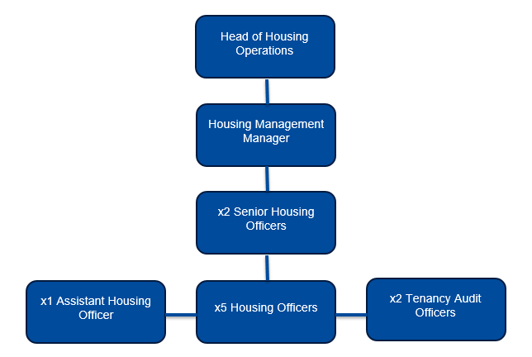

PERSON SPECIFICATION

Candidates must be able to demonstrate, giving examples, all essential criteria marked as A, A/C or A/I within their application form to be shortlisted for this role.

 | Person Specification
 | Essential criteria | How Assessed | Desirable criteria | How Assessed
Qualifications/ Education / Training / Experience | - Experience working in Housing is desirable | A
Qualifications/ Education / Training / Experience | - Willing and able to undertake a professional qualification as required | A
Qualifications/ Education / Training / Experience | - Well developed IT skills with knowledge of Microsoft Office at intermediate level and of housing systems | A
Knowledge /Technical Skills | - Experience of working in a housing management or similar role | A/I
Knowledge /Technical Skills | - Experience of dealing with vulnerable residents | A/I
Knowledge /Technical Skills | - Understanding in health and safety, in particular lone working, asbestos and safeguarding of vulnerable residents | A/I | Awareness of Safeguarding | A/I
Communication | - Ability to communicate clearly and effectively with challenging and/or vulnerable people to achieve the purpose of the post | A/I
Communication | - Understanding of and commitment to promoting equality and diversity in service delivery and employment. | A/I
Customer Service

Customer Service | - If the post requires the postholder to speak to the public as a regular and intrinsic part of their role, please add the following words:  Accurate spoken English is essential for the post | I
Customer Service | - Experience of working in a customer service role that includes supporting vulnerable and challenging individuals and households. | A/I
Team Working | - Effective team and multi-agency working | A/I
Managing self and others | - Ability to manage self and prioritise workload and meet targets in a busy environment | A/I
Managing self and others | - Ability to stay calm and assertive in difficult circumstances | I
Can do approach / Achieving results | - Analytical approach to problem solving | A/I
Can do approach / Achieving results | - Resilience in the face of a challenging workload | A/I
Can do approach / Achieving results | - Take personal responsibility and ownership for decisions, actions and consequences and learns from experience | A/I
ADDITIONAL SPECIFIC REQUIREMENTS FOR THIS POST* | For business continuity purposes you are required to have access to the internet at home via broadband on a PC, laptop or tablet. | A/I
ADDITIONAL SPECIFIC REQUIREMENTS FOR THIS POST* |  |  | Full and valid driving licence | I
ADDITIONAL SPECIFIC REQUIREMENTS FOR THIS POST* | Attend home visits to tenants as required in the role and in accordance with the Business Travel Policy | I

* Please note that Waverley Borough Council cannot guarantee to supply you with the provision of equipment such as laptop, tablet, mobile phone or pool vehicle

How assesed:

A = Application CV/Personal Statement
C = Certificates/professional Registration
D = DBS police check
E = Exercise
I = Interview
M = Medical assessment

For Official Use only
Job title: |  | Post no:
Service: |  | JE score:
Team: |  | Pay band:
Location: | The Burys  Godalming,  Surrey GU7 1HR | Position type:  (if part time, working pattern) | Full time  37 Hours/ Five day week
Competencies:  (level 1 – 4) | Communication: | Add level
Competencies:  (level 1 – 4) | Customer Service:
Competencies:  (level 1 – 4) | Team Working:
Competencies:  (level 1 – 4) | Managing Self and Others: | Add level
Competencies:  (level 1 – 4) | Can do approach/Results:
Reviewed By: |  | Date:
Checked in: | HR | Date:
Last Updated: | Add date | Date:

