

Job Description: Post Title

Waverley is an ambitious authority, committed to being one of the leading Councils in the country at a time of major change by developing a high performing, highly engaged staff team to share the organisation’s values and deliver our corporate objectives.

Job Description
Job title: | Benefit Assessment Officer
Service: | Finance
Team: | Benefits
Location: | The Burys, Godalming, Surrey, GU7 1HR
Reporting to: | Benefit Team Leader
Responsible for: | N/A
Our Organisational Values
Collaboration   | We know, work with and support one another. We collaborate with residents, businesses and partners and realise the potential of the Guildford and Waverley Collaboration. We empower ourselves and others.
  Wellbeing | We look after our own and other’s wellbeing. We know it’s okay to talk to each other about anything we are struggling with. We stay resilient and raise any concerns we have.
Trusted   | We abide by the Nolan Principles of Public Life: Selflessness, Integrity, Objectivity, Accountability, Openness, Honesty, and Leadership.
Value for Money   | We spend public money wisely and carefully. We understand and follow our governance processes and raise any concerns with the right person. We celebrate successes and learn from mistakes.
Professionalism   | We provide professional advice and excellent service, we know our local areas and understand the communities we serve. We listen to all concerns and ideas. We benchmark our performance and always strive to improve.

Principal purpose of the role
- Work as part of a team to achieve the team’s purpose of:
“Providing effective advice and assessing benefits accurately, to the right person, for the right amount, at the right time.”
- Achieve this through using the team’s principles of:
- Understand and do what matters for the customer;
- Only do work that is of value to the customer;
- Work with others to provide a holistic service;
- Take ownership and help customers through the process;
- Focus on the customer, not the process;
Being responsive to customer demand.
Main duties and accountabilities
- Based on a thorough knowledge of Housing Benefit legislation and Council Tax support, use appropriate judgement to:
- Offer comprehensive advice in order to support customers and external agencies with all aspects of Housing Benefit and Council Tax Support;
- Provide accurate advice and information to other internal and external departments/organisations to enable their decision-making processes;
- Support customers by taking ownership of demand from end to end, i.e. from first contact through to decision and explanation, including speaking with other internal and external departments;
- Carry out the scanning and indexing of documents and use of diary dates to monitor future changes;
- Assess new claims and change in circumstances for Housing Benefit and Council Tax Support, including:
- Making decisions on complex claims such as self-employed, students, persons from abroad, adjustments and overpayments;
- Proactively responding to Council tenant sign-ups;
- Work from the DWP such as RTI, ATLAS and Fraud (LAIEF);
- New and evolving national schemes such Universal Credit;
- Setting up and amending Council Tax liabilities and recalculating following the rebanding of Council Tax properties;
- Setting up landlords and making necessary changes to current landlords.;
- Submitting Rent Officer Referrals and assessing Rent Officer Decisions;
- Making decisions on additional elements such as backdates, dual benefit, commercial tenancies, temporary absence, LHA vulnerability and extended payments;
- Being responsible for appropriately accessing DWP data;
- Understanding overpayment legislation to ensure appropriate recovery action is taken and classified correctly for subsidy purposes.
      - Proactively consider, offer and assess DHPs and DCTSFs as part of the assessment process, including consideration of customers’ income and expenditure.
- Offer a mobile assessment service, when necessary, at the Farnham Locality Office and in customer’s homes.
- Identify system errors and escalate to the Benefit Technical Officer.

- Be responsive and flexible to customer demand.
- Take personal responsibility to problem-solve in the work.
- Be aware of failure demand and take a proactive approach with the team to identify and resolve the cause.
- Be conscious of the customer journey and highlight where processes could be improved.

Business Continuity
- Play a pivotal role in business continuity planning and should the need arise assist in ensuring business recovery of key service provision in a 24 hour window.
Health and Safety
Comply with all Health and safety legislation for your area of work, ensuring that risks are identified, managed and monitored as required.
Dimensions of the role
- Deal with a caseload of around 4,500 claims.
- Pay out in the region of £20,000,000 in benefits in a year.
As a team deal with up to 500 phone calls in a month.
Areas of Accountability/Problem Solving – Decision Making / Scope for Impact
- Assess entitlement to and authorise payment of Housing Benefit and Council Tax Support.

- The Benefits Assessment Officer is responsible for taking ownership of the customer journey. Using knowledge of legislation, customers’ circumstances and using discretion, they are accountable for making informed, non-judgemental decisions throughout the process, including:
- Eligibility to claim based upon an in-depth knowledge and understanding of regulations in order to correctly award benefit;
- Requests for backdated benefit by assessing multiple factors such as eligibility and good cause;
- Requests for Discretionary Housing Payments from a budget of in excess of £110,000 through the assessment of income and expenditure, as well as providing budgeting advice and signposting to other organisations;
- Recovery of the newly created overpaid benefit of approximately £25,000 each month, in line with regulations and using judgment of each customer’s situation.

- Take the lead in working with the most challenging and vulnerable customers to support them through the benefit process and ensure longer-term support through partnering with other internal departments and external organisations.

- Work accurately and with minimal supervision to prevent negative impact on the Council’s subsidy claim which takes place on an annual basis, by:
- Correctly awarding benefit;
- Avoiding overpayments;
Maximising subsidy.
Planning/Organising/Controlling
- Manage own workload and time to allow a responsive service to customer demand and to meet the team principles of:
- Understand and do what matters for the customer;
- Only do work that is of value to the customer;
- Work with others to provide a holistic service;
- Take ownership and help customers through the process;
- Focus on the customer, not the process;
- Being responsive to customer demand.

Demonstrate an awareness of the causes of delay in the process, the impact on end-to-end times and subsidy.
Customers and COntacts
Internal
- Staff in other sections of Waverley Borough Council, especially the Resources Department and Housing Department.
External
- Members of the public and/or their representatives;
- All services within the DWP;
- Inland Revenue;
- Landlords, including private and Housing Associations;
- Voluntary bodies.

Service/Team Structure
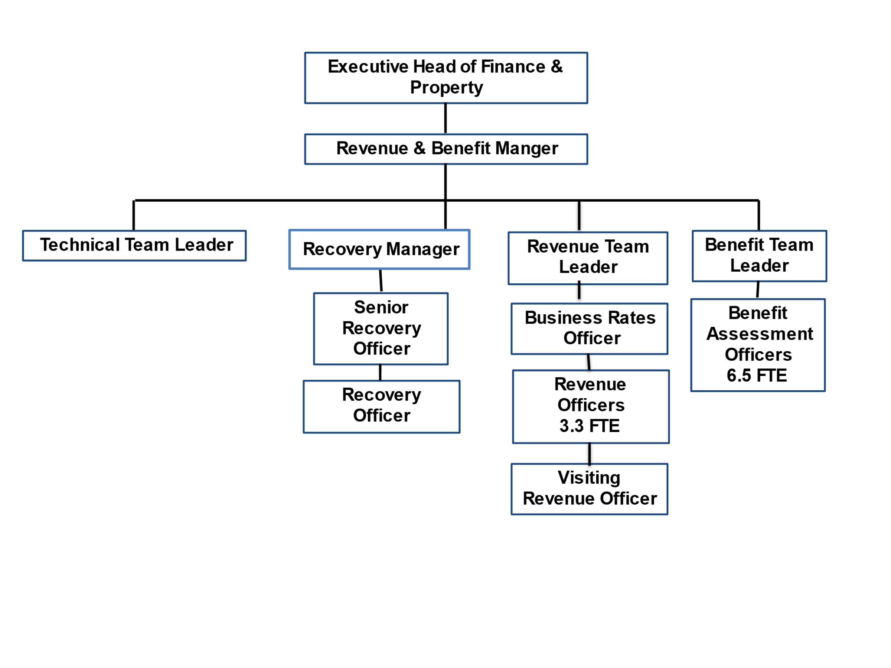
PERSON SPECIFICATION

Candidates must be able to demonstrate, giving examples, all essential criteria marked as A, A/C or A/I within their application form to be shortlisted for this role.

 | Person Specification
 | Essential criteria | How Assessed | Desirable criteria | How Assessed
Qualifications/ Education / Training / Experience | Good general education to GCSE level or equivalent | C | Experience of working in a benefits environment | A
Knowledge /Technical Skills | Experience of working in a customer-focused office environment | A/I | Awareness of Safeguarding | A/I
Knowledge /Technical Skills | In-depth knowledge of Housing Benefit legislation and Council Tax Support or in exceptional circusmtances, a proven ability to learn and apply complex information within a year | A/C/E/I | Experience of a document image processing system (DIPS) | A
Knowledge /Technical Skills | Good general IT skills, able to adapt to new systems and processes | A/I
Knowledge /Technical Skills | Good all round knowledge of state benefits | A/I
Communication | Able to communicate complex and sometimes unwelcome information in an assertive and empathetic manner, verbally and in writing | A/I/E
Communication | Able to handle difficult situations in order to achieve a positive outcome | A/I/E
Communication | Confident telephone manner | A/E
Customer Service | Understanding of and commitment to promoting equality and diversity in service delivery and employment. | I
Customer Service | Accurate spoken English is essential for the post | I
Customer Service | Understand and do what matters to customers | A/I/E
Customer Service | Take ownership of work | A/I
Customer Service | Able to deal with each case objectively, providing the same level of service to a range of customers | A/I/E
Team Working | Work with others to provide a quality service to customers | A/I
Managing self and others | Proactive approach to problem solving | A/I
Managing self and others | Manage own workload and time to allow a responsive service to customer demand | A/I
Managing self and others | Work with conflicting demands | A/I
Managing self and others | Adapt positively to, and be a part of, frequent change | A/I
Managing self and others | Be a skilled and confident decision-maker based on sound judgement and analysis of the facts | A/I
Can do approach / Achieving results | Able to deal with difficult people and situations appropriately | A/I
Can do approach / Achieving results | Work collaboratively with others to achieve positive outcomes | A/I
Can do approach / Achieving results | Attention to detail and work accurately | A/I
Can do approach / Achieving results | Able to understand complex legislation and apply to different scenarios | A/I
Can do approach / Achieving results | Able to make decisions and take responsibility for them | A/I
ADDITIONAL SPECIFIC REQUIREMENTS FOR THIS POST* | For business continuity purposes you are required to have access to the internet at home via broadband on a PC, laptop or tablet. | A

* Please note that Waverley Borough Council cannot guarantee to supply you with the provision of equipment such as laptop, tablet, mobile phone or pool vehicle

How assesed:

A = Application CV/Personal Statement
C = Certificates/professional Registration
D = DBS police check
E = Exercise
I = Interview
M = Medical assessment

Disclosure and Barring Service Check
Due to the nature of the work, this post involves a check on an individual’s criminal background. The check is carried out through the Disclosure and Barring Service (DBS, previously CRB). Any offer of employment will be subject to receiving satisfactory clearance from the Disclosure and Barring Service.

Basic Disclosure Clearance - Government Requirement for Accessing Council and Government Data
To comply with the Public Sector Networks (PSN) “Code of Connection”, Waverley Borough Council, like other public organisations, need to undertake basic disclosure checks for unspent convictions only, in respect of those staff who will access our IT systems.

For Official Use only
Job title: |  | Post no:
Service: |  | JE score:
Team: |  | Pay band:
Location: | The Burys  Godalming,  Surrey GU7 1HR | Position type:  (if part time, working pattern) | Full time  37 Hours/ Five day week
Competencies:  (level 1 – 4) | Communication: | 2
Competencies:  (level 1 – 4) | Customer Service: | 2
Competencies:  (level 1 – 4) | Team Working: | 2
Competencies:  (level 1 – 4) | Managing Self and Others: | 2
Competencies:  (level 1 – 4) | Can do approach/Results: | 2
Reviewed By: |  | Date:
Checked in: | HR | Date:
Last Updated: | Add date | Date:

