

Job Description: Post Title

Waverley is an ambitious authority, committed to being one of the leading Councils in the country at a time of major change by developing a high performing, highly engaged staff team to share the organisation’s values and deliver our corporate objectives.

Job Description
Job title: | Business Rates Officer
Service: | Finance
Team: | Revenues
Location: | The Burys, Godalming, Surrey, GU7 1HR
Reporting to: | Revenue Team Leader
Responsible for: | N/A
Our Organisational Values
Collaboration   | We know, work with and support one another. We collaborate with residents, businesses and partners and realise the potential of the Guildford and Waverley Collaboration. We empower ourselves and others.
  Wellbeing | We look after our own and other’s wellbeing. We know it’s okay to talk to each other about anything we are struggling with. We stay resilient and raise any concerns we have.
Trusted   | We abide by the Nolan Principles of Public Life: Selflessness, Integrity, Objectivity, Accountability, Openness, Honesty, and Leadership.
Value for Money   | We spend public money wisely and carefully. We understand and follow our governance processes and raise any concerns with the right person. We celebrate successes and learn from mistakes.
Professionalism   | We provide professional advice and excellent service, we know our local areas and understand the communities we serve. We listen to all concerns and ideas. We benchmark our performance and always strive to improve.

Principal purpose of the role
- Work as part of a team to achieve the team’s purpose of:
“Give me a quick bill that’s accurate, simple and easy to pay, and if needed, help me get back on track and regain control of my payments.”

- Work responsively and collaboratively within the team, using the principles of:
- Understand and do what matters to each individual customer;
- Use our expertise to satisfy demand our customers don’t know they have;
- Prioritise the customer, not the process;
- Take ownership of customer demand from start to finish;
Where possible, aim to resolve customer’s demand at first point of contact, using the most direct method.
Main duties and accountabilities
- Be responsive and flexible to customer demand.
- Take personal responsibility to problem-solve in the work.
- Be aware of failure demand and take a proactive approach with the team to identify and resolve the cause.
- Be conscious of the customer journey and highlight where processes could be improved.

- Support accurate, prompt and effective billing and collection of Business Rates, thereby, maximising the Council’s collection rate, by:
- Establishing the Business Rates liability;
- Creating and updating Business Rates accounts, including (but not limited to):
- Change of addresses;
- Determinations and awards including Small Business Rate Relief (SBRR),mandatory and discretionary relief;
- Setting up and amending Direct Debits;
- Actioning BACS amendments;
- Actioning Direct Debit recalls in order to understand the customer’s circumstances and establish an appropriate payment method going forward;
- Proactively identifying and processing refunds in a timely manner;
- Updating accounts following re-banding by the Valuation Office Agency (VOA);
- Supporting discount reviews as planned by the Revenue Team Leader and Revenue Technical Officer.

- Based on a thorough knowledge of Business Rates legislation, use appropriate judgement to:
- Offer comprehensive advice in order to support customers and external agencies with all aspects of Business Rates billing;
- Provide accurate advice and information to other internal and external departments/organisations to enable their decision-making processes;
- Support customers by taking ownership of demand from end to end, i.e. from first contact through to issuing the bill, including speaking with other internal and external departments;
- Carry out the scanning and indexing of documents and use of nags to monitor future changes.

- Work with customers, other internal departments, and external agencies to:
- Provide general debt advice and signposting;
- From billing through to summons, make payment arrangements such as spreading instalments or changing payment frequency;
- From liability order stage, set up special arrangements (SPARs), using income and expenditure assessments where necessary.
- Work with SPAR customers who proactively contact us, helping them regain control over their payments;
- Identify complex cases and disputes to hand cases over to the Recovery Officer/Recovery Manager effectively.

- Take responsibility for staying up-to-date with changes in Business Rates legislation.

- During periods of exceptionally high customer demand, support the Revenue Officers by providing cover for essential duties.
- During periods of exceptionally high customer demand, support the Senior Recovery Officer and Recovery Officer by providing cover for essential duties.

Business Continuity
Play a pivotal role in business continuity planning and should the need arise assist in ensuring business recovery of key service provision in a 24 hour window.
Health and Safety
Comply with all Health and safety legislation for your area of work, ensuring that risks are identified, managed and monitored as required.
Dimensions of the role
- Number of domestic dwellings: c.54,000
- Number of businesses: c.4,100
- Annual income collectable: £125.5m
- Annual discount: £8.5m
- Annual exemptions: £1.8m
- Reminders and final demands issued: c. 17,000 pa
- Summons issued: c. 2,200 pa
- Emails and online forms (received monthly, average): 1,600
- Phone calls (received monthly, average): 1,100

Areas of Accountability/Problem Solving – Decision Making / Scope for Impact
- Responsible for taking ownership of the customer journey.
- Using knowledge of legislation, customers’ circumstances and using discretion, accountable for making informed, non-judgmental decisions throughout the process, including:
- Determining liabilities and producing prompt, accurate bills;
- Determining eligibility to a range of discounts and exemptions;
- Considering requests for backdated discounts and exemptions;
- Working with customers to set up realistic and fair payment arrangements, enabling the collection of Business Rates in a sustainable way for customers;
- In more serious cases, following a liability order issued by the court, set up SPARs for monitoring by the Recovery Officer/Recovery Manager.
- Take the lead in working with the most challenging and vulnerable customers to enable them to identify a realistic plan to clear their Business Rates liabilities, utilising support from internal departments and external organisations where appropriate.
- Work accurately and with minimal supervision to prevent negative impact on the Business Rates base by:
- Accurately determining liability, including discounts and exemptions;
- Working on demand in real-time, ensuring the work is up to date and therefore all recovery documents will be valid.

Planning/Organising/Controlling
- Manage own workload and time to allow a responsive service to customer demand and to meet the team principles of:
- Understand and do what matters to each individual customer;
- Use our expertise to satisfy demand our customers don’t know they have;
- Prioritise the customer, not the process;
- Take ownership of customer demand from start to finish;
- Where possible, aim to resolve customer’s demand at first point of contact, using the most direct method.

Demonstrate an awareness of the causes of delay in the process, the impact on end-to-end times and the accuracy of the Council Tax base.
Customers and Contacts
Internal
- Staff in other sections of Waverley Borough Council.
External
- Business Rates customers;
- Chamber of Commerce;
- Members of the public and/or their representatives;
- The Valuation Office and Tribunal Service;
- Landlords, including private and Housing Associations;
- Enforcement Agents and other collecting agencies:
- Court Officials;
- Police Officers;
- The Audit Commission;

Service/Team Structure
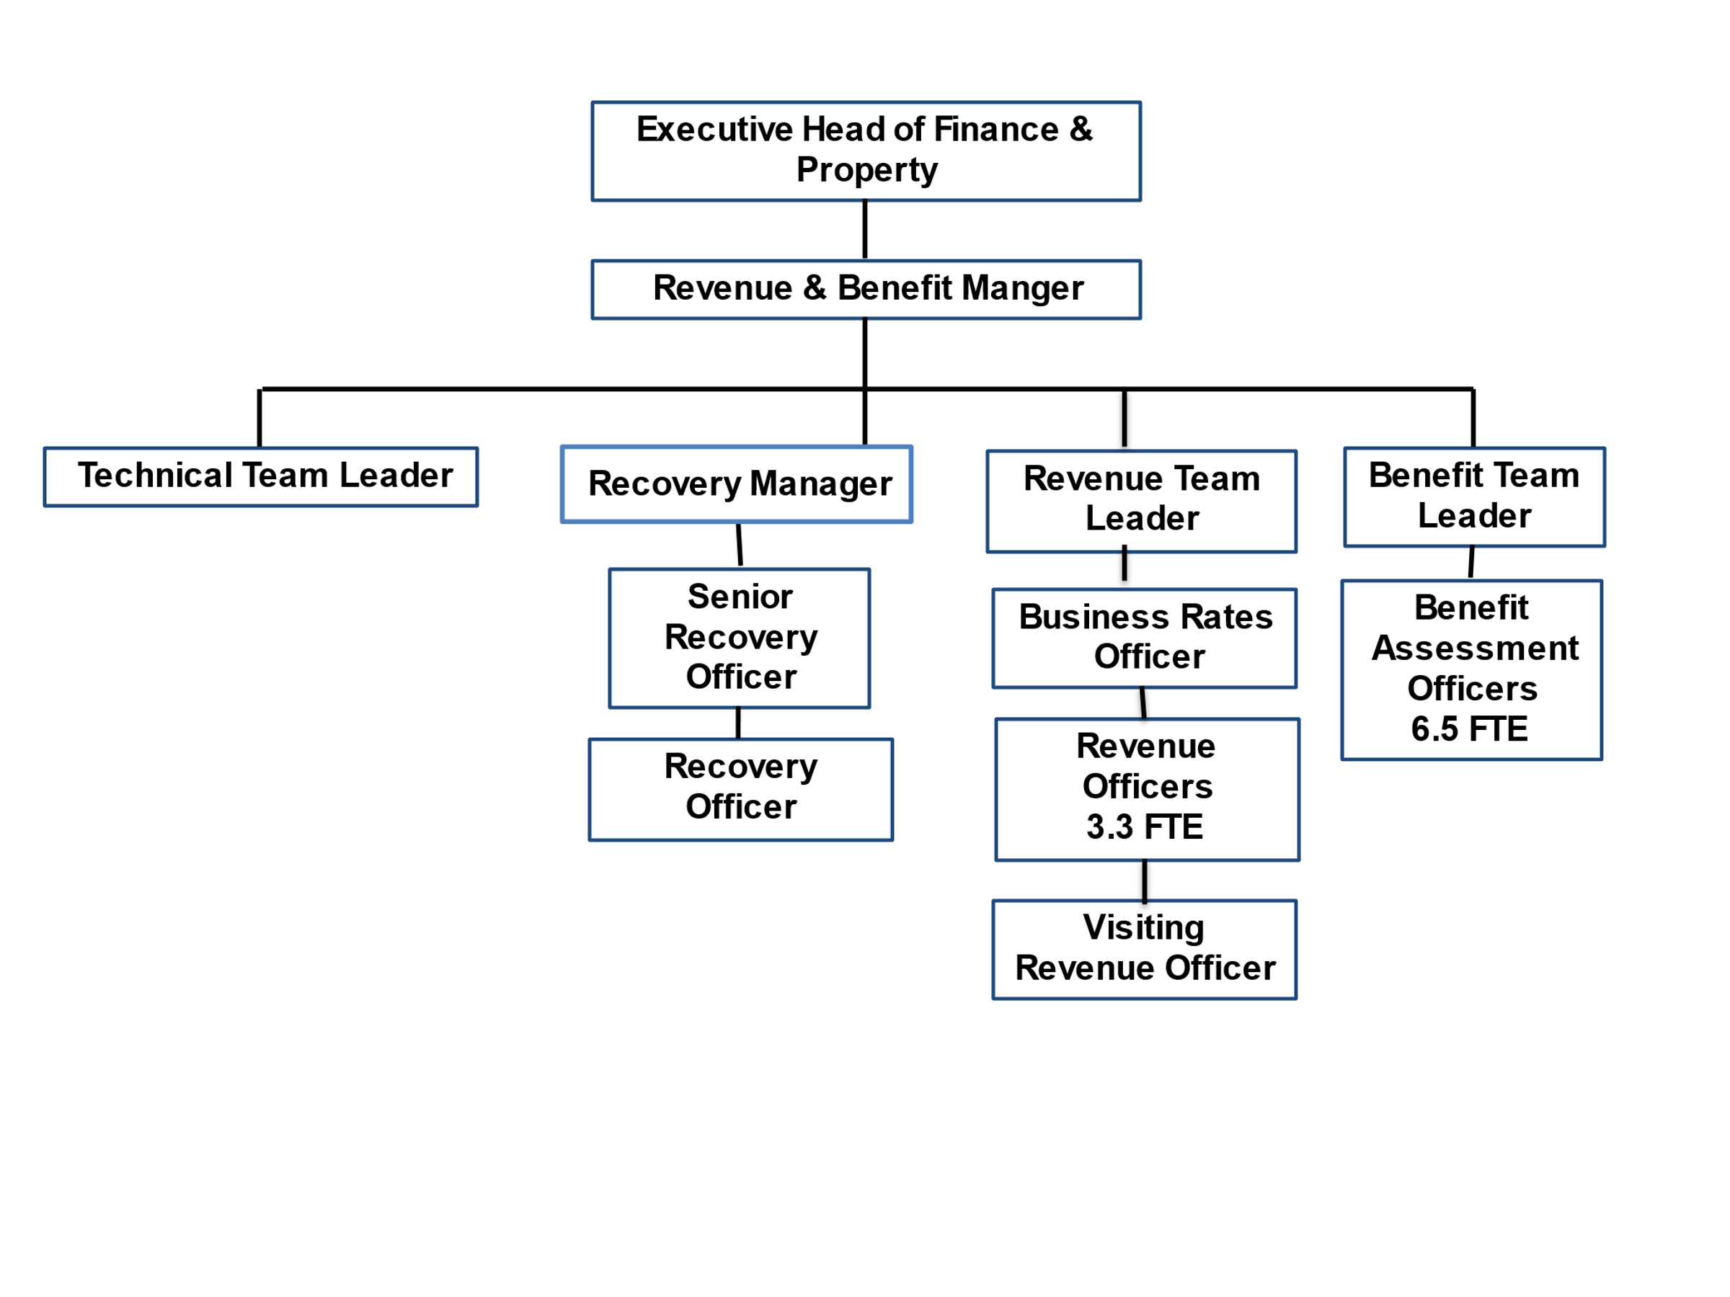

PERSON SPECIFICATION

Candidates must be able to demonstrate, giving examples, all essential criteria marked as A, A/C or A/I within their application form to be shortlisted for this role.

 | Person Specification
 | Essential criteria | How Assessed | Desirable criteria | How Assessed
Qualifications/ Education / Training / Experience | Good general education to GCSE level or equivalent | C | Experience of working in a Council Tax and recovery environment | A
Knowledge /Technical Skills | Experience of working in a customer-focused office environment | A/I | Awareness of Safeguarding | A/I
Knowledge /Technical Skills | In-depth knowledge of Business Rates legislation or in exceptional circumstances a proven ability to learn and apply complex information within a year | A/C/E/I | Experience of a document image processing system (DIPS) | A
Knowledge /Technical Skills | Good general IT skills, able to adapt to new systems and processes | A/I
Communication | Able to communicate complex and sometimes unwelcome information in an assertive and empathetic manner, verbally and in writing | A/I/E | Able to communicate complex and sometimes unwelcome information in an assertive and empathetic manner, verbally and in writing | A/I/E
Communication | Able to handle difficult situations in order to achieve a positive outcome | A/I/E | Able to handle difficult situations in order to achieve a positive outcome | A/I/E
Communication | Confident telephone manner | A/E | Confident telephone manner | A/E
Customer Service | Understanding of and commitment to promoting equality and diversity in service delivery and employment. | I
Customer Service | Accurate spoken English is essential for the post | I
Customer Service | Understand and do what matters to customers | A/I/E
Customer Service | Take ownership of work | A/I
Customer Service | Able to deal with each case objectively, providing the same level of service to a range of customers | A/I/E
Team Working | Work with others to provide a quality service to customers | A/I
Managing self and others | Proactive approach to problem solving | A/I
Managing self and others | Manage own workload and time to allow a responsive service to customer demand | A/I
Managing self and others | Work with conflicting demands | A/I
Managing self and others | Adapt positively to, and be a part of, frequent change | A/I
Managing self and others | Be a skilled and confident decision-maker based on sound judgement and analysis of the facts | A/I
Can do approach / Achieving results | Able to deal with difficult people and situations appropriately | A/I
Can do approach / Achieving results | Work collaboratively with others to achieve positive outcomes | A/I
Can do approach / Achieving results | Attention to detail and work accurately | A/I
Can do approach / Achieving results | Able to understand complex legislation and apply to different scenarios | A/I
Can do approach / Achieving results | Able to make decisions and take responsibility for them | A/I
ADDITIONAL SPECIFIC REQUIREMENTS FOR THIS POST* | For business continuity purposes you are required to have access to the internet at home via broadband on a PC, laptop or tablet. | A

* Please note that Waverley Borough Council cannot guarantee to supply you with the provision of equipment such as laptop, tablet, mobile phone or pool vehicle

How assesed:

A = Application CV/Personal Statement
C = Certificates/professional Registration
D = DBS police check
E = Exercise
I = Interview
M = Medical assessment

Disclosure and Barring Service Check
Due to the nature of the work, this post involves a check on an individual’s criminal background. The check is carried out through the Disclosure and Barring Service (DBS, previously CRB). Any offer of employment will be subject to receiving satisfactory clearance from the Disclosure and Barring Service.

Basic Disclosure Clearance - Government Requirement for Accessing Council and Government Data
To comply with the Public Sector Networks (PSN) “Code of Connection”, Waverley Borough Council, like other public organisations, need to undertake basic disclosure checks for unspent convictions only, in respect of those staff who will access our IT systems.

For Official Use only
Job title: |  | Post no:
Service: |  | JE score:
Team: |  | Pay band:
Location: | The Burys  Godalming,  Surrey GU7 1HR | Position type:  (if part time, working pattern) | Full time  37 Hours/ Five day week
Competencies:  (level 1 – 4) | Communication: | 2
Competencies:  (level 1 – 4) | Customer Service: | 2
Competencies:  (level 1 – 4) | Team Working: | 2
Competencies:  (level 1 – 4) | Managing Self and Others: | 2
Competencies:  (level 1 – 4) | Can do approach/Results: | 2
Reviewed By: |  | Date:
Checked in: | HR | Date:
Last Updated: | Add date | Date:

