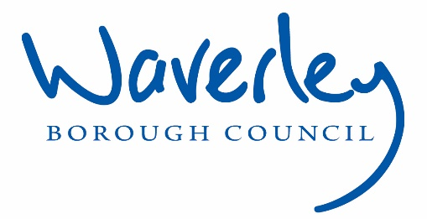

Waverley is an ambitious authority, committed to being one of the leading Councils in the country at a time of major change by developing a high performing, highly engaged staff team to share the organisation’s values and deliver our corporate objectives.

Job Description
Job title: | Planned Works Manager
Service: | Housing Operations
Team: | Property Services
Location: | The Burys, Godalming, Surrey, GU7 1HR
Reporting to: | Housing Operations Manager
Responsible for: | Surveyor x 3  Quality Assurance Officer
Our Organisational Values
Collaboration   | We know, work with and support one another. We collaborate with residents, businesses and partners and realise the potential of the Guildford and Waverley Collaboration. We empower ourselves and others.
Wellbeing   | We look after our own and other’s wellbeing. We know it’s okay to talk to each other about anything we are struggling with. We stay resilient and raise any concerns we have.
Trusted   | We abide by the Nolan Principles of Public Life: Selflessness, Integrity, Objectivity, Accountability, Openness, Honesty, and Leadership.
Value for Money   | We spend public money wisely and carefully. We understand and follow our governance processes and raise any concerns with the right person. We celebrate successes and learn from mistakes.
Professionalism   | We provide professional advice and excellent service, we know our local areas and understand the communities we serve. We listen to all concerns and ideas. We benchmark our performance and always strive to improve.
Principal purpose of the role
- Manage the performance and workloads of the Planned Works Team, leading and managing them to become a cohesive high performing project management team.
- Responsible for the delivery planned maintenance and improvement programme of works, ensuring that projects are delivered on time, the agreed quality achieved and within budget .
- Produce detailed specifications of work and pricing tender documentation to support the procurement of works . Procuring and managing specialist consultants where necessary.
Main duties and accountabilities
Operational
- Lead on the delivery of the planned maintenance programme, ensuring it complies with Council policies, procedures and systems alongside adherence to the compliance of the relevant legal, regulatory and statutory requirements associated with building works.
- Prepare, specifications for investment programs of work for planned improvement and refurbishment projects including tender documentations and pricing schedules of work, liaising with specialist consultants and manufacturers where required to ensure the Council attains and attracts quality contractors when procuring for work.
- Supervise and supports the Planned Works Surveyors in their activities to project manage capital investment projects attending operational and strategic meetings.
- Undertake and manage the more complex and involved capital investment and planned works projects from project inception delivery through to final accounts.
- Complete regular cost analysis of qualitative and quantitive data to drive service improvement and scrutiny of Planned Maintenance works to demonstrate appropriate budget control.
- Hold monthly contract / operational meetings with service providers and develop partnering arrangements, challenge and address failures in performance and monitor day to day activities.
- Manage and coordinate complaints which may arise from improvement programmes, liaising with contractors and tenants to ensure expectations are managed and satisfactory resolutions found.
- Undertake building surveys as required including the preparation of required drawings, schedules of work, pricing rates, bill of quantities, party wall awards, relevant risk and safety plans to develop and support business case decision making.
- Support the Project Coordinator to complete Planning and Building Control submissions, including consultation with the local Planning Conservation Officer and English Heritage, providing technical guidance and expertise.
- Provide support and guidance to Housing Operations colleagues and the wider Council services as appropriate.
- To act as the client representative in respect of the CDM regulations.
- Diagnose building defects, recommend and undertake the most appropriate action.
- Responsible for ensuring that the Council’s properties, communal areas and estates are well maintained and that a proactive approach is taken to the overall improvement of standards including cross-team working.
- Support the delivery of the Asset Management Strategy, Procurement Strategy and Housing Service Plan
- Support the Community and Estates Development Officer in community upgrade works including (but not withstanding carparking, curtilage and pathways

Financial
- Take responsibility for the delivery of the Capital Works budget which in totality is in excess of £3-5m ensuring that it is delivered on time and within budget thresholds, providing support to the Planned Works Surveyors
- Challenge and escalate concerns in relation irregularities in applications for payment, conforming to the contractual obligations, terms and conditions.
- Provide information to the Strategic Asset Manager and Housing Finance Officer to enable budget setting and business planning

Contract Management
- Ensure that all qualifying works are procured in line with the Councils Contract Procurement Regulations and Financial Regulations.
- Attend and chair operational and strategic meetings to support decision making process and ensure programme progression against agreed timescales are being achieved alongside high resident satisfaction and that performance and contractual issues are addressed and resolved.
- Monitor and record contractor performance producing Key Performance Indicator reports providing monthly performance reports for presentation to Housing Operations Manager
- Ensure that contracts are compliant with H&S legislation and regulations alongside the Councils policy and procedures; liaise with the Compliance Manager to escalate issues or seek clarification on matters arising.

Staff Management and Training
- Lead and manage the Planned Maintenance Team from recruitment & selection, induction, training & ongoing development with regular 1-2-1s and appraisals.
- Support the development and training of staff as required, ensuring available skills are in place to meet business objectives and enable staff to meet their potential.

Team Work and Communication
- To contribute to partnership working with internal and external partners, initiate and develop a cohesive and consistent approach to improved methods of working and processes.
- Provide technical leadership and guidance within Housing Operations this includes supporting the Planned Works Surveyors, Housing Maintenance Inspectors, and Customer Service Team.
- Support the Resident Support Officer in their work with tenants and leaseholders (including Section 20 consultation work) who are undergoing planned improvement works in their homes; attending consultation meetings and providing technical advice and guidance in a manner that can be understood by a non-technical audience.

Customer Service
- Corporate – Deliver excellent service to customers in line with published service standards
- Equality and Diversity – Actively promote the Council’s Equality and Diversity policy in all aspects of your duties
- Safeguarding – Adhere to effective safeguarding practices for vulnerable adults and children in accordance with the Councils policies, guidance and protocol
- Dignity and Respect – Treat all colleagues with dignity and respect whilst at work so that they are able to, and encouraged to meet their full potential by working in a non-threatening environment free of harassment and/or bullying
- Data Protection - Ensure that the principle of confidentially and the requirement to adhere to GDPR are fully applied to the work of your service area.
- Information Sharing – Work in line with the relevant protocols and service level agreements to enable the effective sharing of information between agencies.

Business Continuity
- Play a pivotal role in business continuity planning and should the need arise assist in ensuring business recovery of key service provision in a 24 hour window.

Health and Safety
- Comply with all Health and safety legislation for your area of work, ensuring that risks are identified, managed and monitored as required.
- Have a clear understanding of the Control of Asbestos Regulations 2012 and that the Council’s Asbestos policies and procedures are adhered to, taking appropriate action, reporting any cases as required.
- Have a clear understanding of the client and contractor roles under CDM regulations.

Dimensions of the role
- Maintenance of Council housing stock, approx. 5000 homes.
- Planned Works and Cyclical Budget - circa £3m-5m
- Management of up to 6 team members
- Contracts – circa 10 (likely to increase)
- Cyclical Works Completed - circa 1000 pa
- Operational Meetings to Chair – approximately 50 pa
- Strategic Meetings - approximately 30 pa

Areas of Accountability/Problem Solving – Decision Making / Scope for Impact
- Ensure the Planned Maintenance Team project manage and delivery capital works within the allocated budgetary values of £3-5mmillion per annum ensuring value for money
- Ensure that Planned Maintenance Team are adequately trained and resourced effectively, and ensure ongoing continuous professional development
- Provide cost analysis for budget reporting and setting of planned maintenance budgets
- Provide technical support and guidance to Housing Operations colleagues to support decision making
- Approval of payments in accordance with the Council’s Scheme of Delegation.
- Audit, review and authorise variation orders, applications for payment and invoices in accordance with the Council’s Scheme of Delegation.

Planning/Organising/Controlling
- Assessing component condition, lifecycle and cost to assist in developing consolidated rolling programme of investment works.
- Assist the Asset Management Team to determine appropriate scope of works in order to produce investment programmes.
- Providing technical expertise and advice to the wider team as required.
- Ensure daily provision of survey data so that this can be proactively utilised by the Asset Management Team contributing to the delivery of the Asset Management Strategy and input into periodic reviews.
- Support collaborative and cross functional working, sharing resources across the Asset Management Team, Property Services Team and the wider Housing Service to meet operational targets and priorities.
- Ensure that accurate records are maintained, to ensure stock data and performance monitoring data is update to date and current.

Customers and Contacts
Internal
- All staff including the Management Board, Executive members including portfolio holders for Housing Services.

External
- Tenants, leaseholders, tenant & resident groups, members of the public, service providers and other agencies and partners.

Service/Team Structure
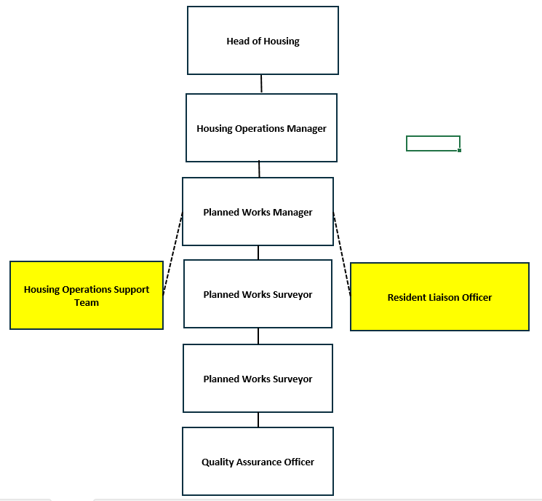

PERSON SPECIFICATION

Candidates must be able to demonstrate, giving examples, all essential criteria marked as A, A/C or A/I within their application form to be shortlisted for this role.

 | Person Specification
 | Essential criteria | How Assessed | Desirable criteria | How Assessed
Qualifications/ Education / Training / Experience | Higher level technical qualification (eg HND/C) in building surveying/ relevant subject or equivalent by experience | A/I/C | Educated to degree level in Building Surveying or other relevant technical field | A/I
Qualifications/ Education / Training / Experience | Evidence of Continued Professional Development | A/C | Experience of acting as a CDM Co-coordinator on Planned Works Projects | A/I
Qualifications/ Education / Training / Experience | Well-developed IT skills with knowledge of Microsoft Office at Intermediate level | A/C | Experience of working within social housing | A/I
Qualifications/ Education / Training / Experience | Clear practical understanding of the client and designer roles in CDM regulations | A/I/E | Evidence of adherence to Party Wall Act legislation | A/I
Qualifications/ Education / Training / Experience |  |  | Knowledge of managing works on specialist buildings included listed or conservation buildings | A/I
Qualifications/ Education / Training / Experience |  |  | Professional membership of RICS, CIOB or equivalent | A/C
Knowledge /Technical Skills | Experience of cost analysis, budgetary management, audit and review of management and financial information to drive performance improvement | A/I | Experience of working in social housing | A/I
Knowledge /Technical Skills | Ability to manage, lead and develop high performing teams | A/I | Awareness of Safeguarding | A/I
Knowledge /Technical Skills | Having experience of a similar surveyor role leading large programmes or work managing contractors | A/I | Experience of contract procurement within public sector | A/I
Knowledge /Technical Skills | Working knowledge of forms of building contract including JCT Measured Term, Minor Works and Termed Partnering Agreements | A/I/E | Knowledge of central governments Decent Homes objectives and criteria | A/I
Communication | Demonstrate effective contract administration, dealing with challenging situations and negotiate changes to improve service delivery | A/I | Ability to negotiate to meet mutually beneficial outcomes | A/I
Communication | Production of detailed written reports and effective verbal presentation skills | A/I/E
Communication | Ability to encourage open discussion and feedback amongst team and key stakeholders | A/I
Communication | Ability to communicate clearly and effectively ensuring that complex technical information is understood by a non-technical audience | A/I
Customer Service | Understanding of and commitment to promoting equality and diversity in service delivery and employment. | A/I
Team Working | Display ability to direct, inspire & empower the team | A/I
Team Working | Experience of building constructive and productive internal/external relationships | A/I
Team Working | Exhibit commitment to continually improving team performance | A/I
Team Working | Demonstrate the ability to delegate | A/I
Managing self and others | Experience of providing clear, measurable outcomes, keeping a rigorous focus on whether they are being achieved | A/I | Exhibit ability to support a culture which positively responds to change | A/I
Managing self and others | Ability to review performance data, understand the impact and decisively act where performance falls below expectations | A/I/E
Managing self and others | Ability to support and provide clarity to individuals whilst holding them accountable for results or taking action if performance falls | A/I
Can do approach / Achieving results | Demonstrate an awareness of cost and budget implications in order to provide advice and recommendations for the setting of appropriate budgets | A/I
Can do approach / Achieving results | Experience of using data from a wide range of sources (including the customer) to drive both improvement and cost-efficiency across the service | A/I
Can do approach / Achieving results | Ability to develop clear, SMART plans which will detail performance targets, resource & activities required to achieve objectives | A/I
ADDITIONAL SPECIFIC REQUIREMENTS FOR THIS POST | For business continuity purposes you are required to have access to the internet at home via broadband on a PC, laptop or tablet. | A
ADDITIONAL SPECIFIC REQUIREMENTS FOR THIS POST | Full and valid driving licence and use of a car during working hours | A/I
ADDITIONAL SPECIFIC REQUIREMENTS FOR THIS POST | Ability to undertake surveying activities including climb ladders, working at height and accessing loft spaces | A/I
ADDITIONAL SPECIFIC REQUIREMENTS FOR THIS POST | Occasional attendance outside normal working hours | A/I

How assessed
A = Application CV/Personal Statement
C = Certificates/professional Registration
D = DBS police check
E = Exercise
I = Interview
M = Medical assessment

For Official Use only
Job title: | Planned Maintenance Manager | Post no: | HF06
Service: | Housing Operations | JE score: | 398
Team: | Property Service Team | Pay band: | 5
Location: | The Burys  Godalming,  Surrey GU7 1HR | Position type:  (if part time, working pattern) | Full time  37 Hours/ Five day week
Competencies:  (level 1 – 4) | Communication: | 2
Competencies:  (level 1 – 4) | Customer Service: | 2
Competencies:  (level 1 – 4) | Team Working: | 2
Competencies:  (level 1 – 4) | Managing Self and Others: | 2
Competencies:  (level 1 – 4) | Can do approach/Results | 2
Reviewed By: | Operations Manager | Date: | July 2024
Checked in: | Human Resources…? | Date:
Last Updated: | January 2023 | Date:

