

Job Description: Business Administration Apprentice

Waverley is an ambitious authority, committed to being one of the leading Councils in the country at a time of major change by developing a high performing, highly engaged staff team to share the organisation’s values and deliver our corporate objectives.

Job Description
Job title: | Business Administration Apprentice
Service: | Commercial Services
Team: | Waverley Training Services
Location: | Farnham Memorial Hall, Babbs Mead, West Street, Farnham,  GU7 7EE
Reporting to: | Data and Administration Manager
Responsible for: | N/A
Our Organisational Values
Collaboration   | We know, work with and support one another. We collaborate with residents, businesses and partners and realise the potential of the Guildford and Waverley Collaboration. We empower ourselves and others.
  Wellbeing | We look after our own and other’s wellbeing. We know it’s okay to talk to each other about anything we are struggling with. We stay resilient and raise any concerns we have.
Trusted   | We abide by the Nolan Principles of Public Life: Selflessness, Integrity, Objectivity, Accountability, Openness, Honesty, and Leadership.
Value for Money   | We spend public money wisely and carefully. We understand and follow our governance processes and raise any concerns with the right person. We celebrate successes and learn from mistakes.
Professionalism   | We provide professional advice and excellent service, we know our local areas and understand the communities we serve. We listen to all concerns and ideas. We benchmark our performance and always strive to improve.

Principal purpose of the role
- To provide administration support to all areas of Waverley Training Services in line with the needs of the business.

Main duties and accountabilities
- To have at all times excellent attention to detail ensure all information is accurate, submitted and stored correctly without error.
- Assist in the maintaining of Learner records using learner management system PICS including adding new starts and recording completions.
- To assist in registering Learners for qualifications and checking results.
- Provide a reception service by ensuring all telephone calls and emails are answered in line with company policy and in a timely manner.
- Assist with customer enquiries both on the phone and via email and judge how best to assist and signpost accordingly.
- Assist in the bookings of exams for Apprentices and supporting with invigilation of exam sessions complying with examination guidance.
- Sign for and receive parcels, documents, and post.
- Attend meetings and taking minutes.
- Responsible for assisting in general office duties, such as scanning, posting, and maintaining office supplies.
- Completing the minimum of 6 OTJH (Off the job hours) a week to support with your Apprenticeship work and attend all lessons with your allocated Tutor.
Business Continuity
- Play a pivotal role in business continuity planning and should the need arise assist in ensuring business recovery of key service provision in a 24-hour window.
- Health and Safety
Comply with all Health and safety legislation for your area of work, ensuring that risks are identified, managed, and monitored as required.

Dimensions of the role
Under close Supervision the post holder will play a key role in the development and delivery of the Services provided by Waverley Training Services by assisting with:

- Adhering to policies, procedures, and processes.
- Processing new Learner sign ups.
- Assisting with enquiries received by Waverley Training Services.
- Providing excellent customer service.
- Providing support in line with the needs of the business.

Areas of Accountability/Problem Solving – Decision Making / Scope for Impact
Milestone | Our commitment to you | Expectations
3 Months | - To deliver a thorough induction and initial training to support you in settling into your role.  - To provide a supportive team environment.  - To provide training on relevant I.T systems.  - To allocate Apprenticeship OTJ for completing Apprenticeship work. | - To attend an Apprenticeship Induction.  - To attend a Council induction.  - To complete all required induction E-Learning.  - To be punctual.  - To demonstrate commitment to your qualification by attending all lessons and completing OTJ weekly, logging learning activity and submitting work in a timely manner.  - To attend 12-week progress review with your Tutor and Line Manager.  - To attend 1-2-1 monthly meetings with line manager.
6 Month | - Provide the tools to support you in delivering excellent customer service.  - To provide training on Awarding organisation and End Point Assessment systems.  - To allocate Apprenticeship OTJ for completing Apprenticeship work.  - Reviewing policies, processes and annual reviews of legislation and guidance from governing bodies such as Apprenticeship funding rules and Safeguarding guidance. | - To have a positive approach to learning and personal development.  - To deal with all stakeholders in a polite, friendly, helpful and respectful manner.  - To demonstrate commitment to your qualification by attending all lessons and completing OTJ weekly, logging learning activity and submitting work in a timely manner.  - To attend 12-week progress review with your Tutor and Line Manager.  - To attend 1-2-1 monthly meetings with line manager.
12 Month | - To allocate Apprenticeship OTJ for completing Apprenticeship work.  - Provide you with the tools to support you with delivering project management, reviewing policies, processes and annual reviews of legislation and guidance from governing bodies. | - Commitment to developing your existing knowledge to enable you to perform administrative tasks effectively.  - To attend 1-2-1 monthly meetings with line manager.  - To continue to support WTS with daily administration duties and larger projects when required.
15-24 Month | - Assist with developing your cv and support with applications for positions both internal and external to the council.  - To allocate Apprenticeship OTJ for completing Apprenticeship work.  - To provide support in preparing for End Point Assessments including all components. | - Complete work on EPA project and attend End Point Assessment, sitting all components to complete your qualification.  - To attend 1-2-1 monthly meetings with line manager.

Planning/Organising/Controlling
The post holder is required to:
- Organise their own workload.
- Manage a variety of tasks and projects at any one time and meet the deadlines.
- Be a positive, effective, and participative team member collaborating with colleagues to balance workload and deliver excellent customer service.

Customers and Contacts
Internal
- Centre Manager, Councilors, Waverley Borough Council employees and colleagues.
External
- Department of Education, Education and Skills Funding Agency, Learners, Awarding Organisations (AO), End Point Assessment Organisations (EPAO) Employers, Learners, Parents, visitors reporting to WTS offices

Service/Team Structure
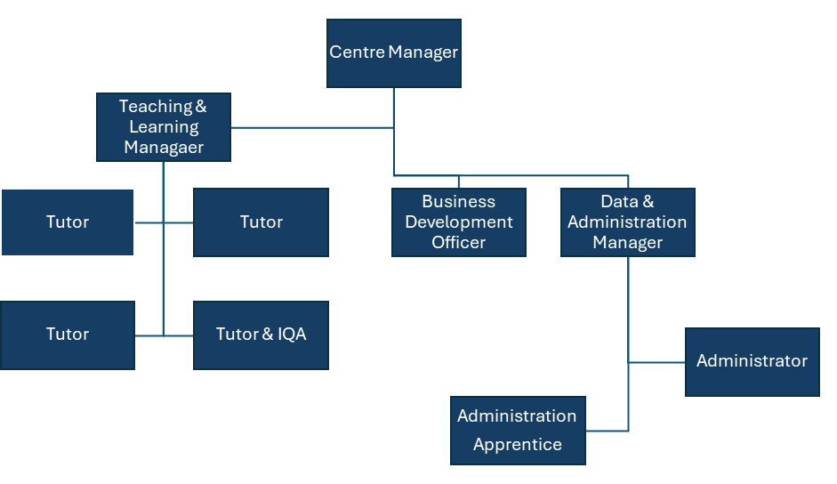

PERSON SPECIFICATION

Candidates must be able to demonstrate, giving examples, all essential criteria marked as A, A/C or A/I within their application form to be shortlisted for this role.

 | Person Specification
 | Essential criteria | How Assessed | Desirable criteria | How Assessed
Qualifications/ Education / Training / Experience | - English and Math GCSE 9-4 (A*- C) or equivalent e.g., Functional Skills L2 | A/C
Knowledge /Technical Skills | Good IT skills: Knowledge of Microsoft Word and Excel. | A/I | Ability to use Microsoft Office: Outlook and PowerPoint. | A/I
Knowledge /Technical Skills | Excellent attention to detail and accuracy. | A/I | Awareness of Safeguarding. | A/I
Communication | Good verbal and written communication skills. | A/I
Communication | Experience of using a range of different communication methods (e.g., telephone, email, and video call). | A/I
Customer Service | Understanding of and commitment to promoting equality and diversity in service delivery and employment. | I | Previous work experience delivering customer service (e.g., hospitality, retail, or volunteer). | A/I
Customer Service | Able to accurately record customer requests. | A/I
Customer Service | Good customer service skills. | I
Team Working | Collaborate with other people to achieve shared goals. | A/I | Experience of working in a team- either volunteer or paid employment. | A/I
Team Working | Treat everyone with respect. | A/I
Managing self and others | Reliable | A/I
Managing self and others | Ability to manage own workload. Able to meet deadlines | A/I | Experience at meeting deadlines within an educational setting, volunteer, or paid employment. | A/I
Can do approach / Achieving results | Takes pride in work | A/I | Experience of making an improvement e.g., in a school/ college project or work/ volunteer. | I
Can do approach / Achieving results | Keen to learn and develop new skills. | A/I |  | I
Can do approach / Achieving results | Ability to work under pressure independently and as part of a team. | A/I |  | I
ADDITIONAL SPECIFIC REQUIREMENTS FOR THIS POST* | For business continuity purposes you are required to have access to the internet at home via broadband on a PC, laptop, or tablet. | A/I

* Please note that Waverley Borough Council cannot guarantee to supply you with the provision of equipment such as laptop, tablet, mobile phone or pool vehicle

How assessed:

A = Application CV/Personal Statement
C = Certificates/professional Registration
D = DBS police check
E = Exercise
I = Interview
M = Medical assessment

Disclosure and Barring Service Check
Due to the nature of the work, this post involves a check on an individual’s criminal background. The check is carried out through the Disclosure and Barring Service (DBS, previously CRB). Any offer of employment will be subject to receiving satisfactory clearance from the Disclosure and Barring Service.

For Official Use only
Job title: | Administration Apprentice | Post no:
Service: | Commercial | JE score:
Team: |  | Pay band:
Location: | Farnham Memorial Hall  Babbs Mead  West Street  Farnham  Surrey  GU9 7EE | Position type:  (if part time, working pattern) | Full time  37 Hours/ Five-day week
Competencies:  (level 1 – 4) | Communication: | 1
Competencies:  (level 1 – 4) | Customer Service: | 1
Competencies:  (level 1 – 4) | Team Working: | 1
Competencies:  (level 1 – 4) | Managing Self and Others: | 1
Competencies:  (level 1 – 4) | Can do approach/Results: | 1
Reviewed By: |  | Date:
Checked in: |  | Date:
Last Updated: |  | Date:

