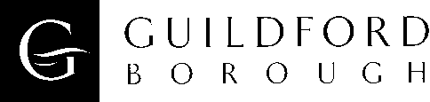

Job Title: | Policy Officer (Urban Design)
Job purpose
- To provide specialist design advice and to promote high standards of design within the borough.

Main duties
- Provide design and place-making advice in the evaluation and negotiation of a wide range of planning applications, key development projects and other related matters.

- To represent the Borough at pre and post application meetings with developers, their architects and agents, and to negotiate with all parties to ensure a high standard of development.

- To assist with the preparation of urban design guidance, design policy, planning briefs and masterplans for major development sites within the borough (graphic, written and verbal).

- To contribute to the preparation of the Local Development Framework documents, Supplementary Planning Documents, planning and development briefs within the Council’s functions relating to Urban Design.

- To attend meetings of the Council as may be required, including public meetings and consultation events.

- To represent the Council at Public Inquiries and Informal Hearings as the Council’s expert witness on such matters arising from the work of the service.

- To contribute to the Council’s Corporate Plan in conjunction with the Conservation and Design team leader.

- To promote and champion urban design to the wider public generally.

- Participate in training and briefing sessions (internally and externally) as required and maintain a record of professional development undertaken.

