Civic Offices
Gloucester Square
Woking
Surrey
GU21 6YL

Telephone (01483) 755855
Facsimile (01483) 768746
Email wokbc@woking.gov.uk
Website www.woking.gov.uk

1 July 2022

Dear Candidate,

Head of Planning

Thank you for your interest in this post.

I joined the Council just over a year ago and quickly recognised the hard working and can-do attitude of its staff and members. Over that time, we have set out our ambition and objectives in our Corporate Plan and reconfirmed and added to those by publishing our new Administration’s priorities.

The planning service has achieved so much in the last year, the adoption of our site allocations development plan document, the completion of a Planning Peer Review and the advancement of a new Masterplan for the town centre to name but a few.

The Head of Planning will be pivotal in supporting the delivery of the corporate plan both directly through the work of their team and by working as a critical member of our newly formed Place Directorate Management Team. The post holder will be in a unique position to drive forward our masterplan to adoption and begin work on the review of the Local Plan and its replacement. Working collaboratively and in partnership will be essential to meet our place making ambitions for the Borough.

I look forward to discussing this opportunity with you.

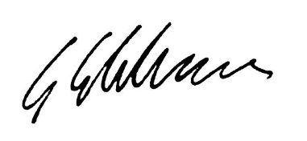
Yours sincerely,

Giorgio Framalicco
Director of Planning

Key Documents / Links:

Corporate Plan – Woking for all Strategy

Supplementary and amended priorities – Woking for all Strategy

Planning Directorate Plan

Neighbourhood Directorate Plan

Planning Peer Report Item 7b

Surrey 2050 Place Ambition Item 10

The Local Plan including our Site Allocations Development Plan Document

